High Level Design

**Emerging Solutions**

SALT 4.2 modifications (4.2.1)

Document Version – 1.02

**07/09/2011**

Document Identification

| **Project** | Salt v4.2.1 |
| --- | --- |
| **Project Manager** | Ashley Moore |
| **Document Title** | High Level Design |
| **Author** | John Hedlefs, Hitendra Jagtap |
| **Filename** | SALT 4 2 1 HLD v0 1 20110906 |
| **Version** | 1.02 |
| **Modification Date** | Wednesday, 07 September 2011 |

Version History

|  |  |  |  |  |
| --- | --- | --- | --- | --- |
| **Version** | **Date** | **Author(s)** | **Details** | **Status** |
| Draft 1 |  | John Hedlefs, Hitendra Jagtap | Draft |  |
| Draft 2 |  | John Hedlefs, Hitendra Jagtap | Draft |  |
| Draft 3 |  | John Hedlefs, Hitendra Jagtap | Draft |  |
| Draft 4 | 02/09/2011 | John Hedlefs, Hitendra Jagtap | Incorporated comments from Wednesday, 31 Aug 2011 meeting  Modified CC list interface in Section 1  Modified complete Section 4 along with new screenshots  Added “Export” functionality to section 2 and section 3  Modified Section 9: “Stop Emails”  Modified Section 6: MyTraining screenshots  Added XML import users scenario in section 5 |  |
| Draft 5 | 06/09/2011 | John Hedlefs, Hitendra Jagtap | Incorporated comments from  Monday , 5 Sep 2011 meeting.  Change BMP for periodic controls, CC:list popup, add section for Reassign popup, change BMP for periodic Reports Grid, delete-reassign popup, reword section 9. |  |
| Draft 6 | 07/09/2011 | John Hedlefs, Hitendra Jagtap | Incorporated comments from Wednesday, 7 Sep 2011 meeting.  Changes to Report Schedule CC: list maintenance popup.  Replace fig 9 which was deleted in error.  Modifications to CC:list popup.  Modifications to the Reassign Report Schedule to another user popup  Modifications to Stop Emails |  |
|  |  |  |  |  |
|  |  |  |  |  |
|  |  |  |  |  |
|  |  |  |  |  |
|  |  |  |  |  |
|  |  |  |  |  |

Contents

1 Report pages have additional periodic scheduling controls. 5

Requirement: 5

Proposal: 5

Proposed layouts for Periodic controls: 9

2. Required on Period Report screen for Org Admins 22

Requirement: 22

3 Additional fields required on Period Report screen for SALT Admins 28

Requirement: 28

Proposed screenshot: 29

4. Delete/Re-assign Reports to another user when a User is made inactive. 29

5. Allow import files to update existing users and Additional fields in import files 34

Requirement: 34

5.1 New Fields 35

5.2 Behaviour of “Update Imports” 37

6. Modifications to “My Training” page 38

Requirement: 38

Proposed modifications screens: 39

7. Provide a Rich Text editor on the existing “Org Config” screen 41

Requirement 41

Proposed Screens: 41

Requirements 42

8. Ability to disable manager notifications at course level and to produce summaries or individual notifications. 43

8.1 Ability to disable manager notifications 44

8.2 Ability to modify notification options for each course 44

8.3 Ability to produce summaries or individual notifications. 44

8.4 Ability to produce summaries at frequencies other than one day. 44

9. Provide a feature that allows admins to temporarily stop emails. 45

10. Replace the user of the word “Delinquency” or “Delinquent” with ”Overdue”. 51

Requirement 51

11. reports are grouped by category 52

Requirements 52

Implementation 53

Testing 53

12. Historic Admin Report default date mod. 53

13. Licensing Report control changes. 55

14. Add a %FirstName% parameter substitution variable to all Reports. 55

Appendix 1 60

new fields in tblReportSchedule 60

definition of new table tblSchedulesAudit 62

definition of new table tblOrganisationCourseNotifyOptions 64

# Report pages have additional periodic scheduling controls.

Requirement: Allow unit, organisation, and SALT admins to create periodic reports from the same screen as the manual reports for the reports given below:

* Active/Inactive Users Report
* At Risk Report
* CPD Report
* Completed Users Report
* Course Status Report
* Current Admin Report
* Licensing Report
* Policy Builder Report
* Progress Report
* Summary Report
* Trend Report
* Warning Report

## Proposal:

The above mentioned reports can be divided into 2 categories:

1. Reports having no date controls are:

* CPD Report
* Current Admin Report
* Licensing Report
* Progress Report
* Warning Report

1. Reports having 1 (Historic or Effective date) or 2 (Date from and Date to, or, Between to) date controls are:

* Active/Inactive Users Report
* At Risk Report
* Completed Users Report
* Course Status Report
* Policy Builder Report
* Summary Report
* Trend Report

The “Run Report” button will behave as it does now, it will render the Reporting Services Report in a panel that provides a toolbar containing pagination and exporting controls.

The “Reset” button beside the “Run Report” button will clear the values from all of the controls above this “reset” button.

Report Schedules will be owned by a single individual and that individual is the only Recipient on the To: list

When the owner of the Scheduled Report is made inactive, SALT does not send the Scheduled Report to owner and any of the recipients via email until the owner of the Scheduled Report is made active.

Report Schedules must be given a name to identify different schedules in the users list of schedules (For example ‘Quarterly Progress Summary’ or ‘Daily Progress Summary’). This will be the “Report Title” of the periodic report. Its default text will be the Report Type name. The “Report Title” will appear in the subject of the email sent. The format of the subject of the email will be:

*<Application Name>* Report: *<Report Title>*

Note: The Organisation for which the periodic report will be created, will be derived from the owner of the report who creates the periodic report.

For the reports that can be scheduled, the periodic controls will be shown below the “Run Report” button. There will be 3 options for scheduling when the report is to be delivered and how many times:

1. Now
2. Once Only
3. More than once

There will be a “Send/Save” button at the bottom to save the schedule and/or send the report.

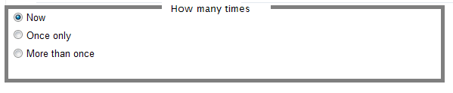

When “Now” is selected and the “Send/Save” button is pressed a request to email the Report to the Report owners email address (and any other additional recipients selected as CCs) at the earliest moment possible will be queued. (A one-off Report Schedule will be created and will be processed based on relevant rules relating to priorities of Reporting Services Emails vs. user webpage requests etc. and any other devices such as “Stop mail” controls on org mail setup and mail throughput screens. The Report Schedule will not appear on any list of schedules. When the Report Schedule is processed it will be deleted. If the Reports Recipient is flagged “Inactive” at the time of processing the Schedule will be deleted without any emails being raised) The “Report Title” field is ignored when the “Now” Radio Button is selected – i.e. it is not saved and never appears on any emails. When a schedule is deleted no record is kept of the schedule ever having existed (for audit purposes).

When “Once only” is selected a date control is displayed and this date control must be populated before the “Send/Save” button can be pressed (validation behaves as per all existing controls). When the “Send/Save” button is pressed a request is created to email the Report to the Report owners email address (and any other additional recipients selected as CCs) as soon as possible after 00:00:00 in the Organisation’s Time zone (and also after the overnight job runs for that organisation) on the day selected in the date control. (A once-off Report Schedule will be created and will be processed based on relevant rules, such as “Stop mail” controls on mail throughput screens. The Report Schedule will appear on lists of schedules. When the Report Schedule is processed it will be deleted. If the Reports Recipient is flagged “Inactive” at the time of processing the Schedule will be deleted without any emails being raised)

When “More than Once” is selected the following controls will appear:

* A “Start date” date control
* An “Every” control
* A “No end Date”-“End after”-“End On” Radio Group List of buttons
* A “Number of reports” text box (and label)
* An “End on” date control

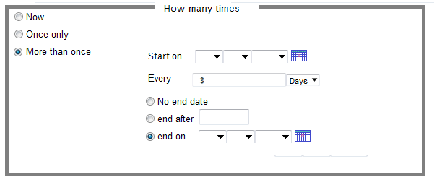

The “Start date” date control and the “Every” control must be populated before the “Send/Save” button can be pressed (validation behaves as per all existing controls). The “Start Date” is the date from which the report is first created and delivered. “Start Date” cannot be a date in the past.

The “Every” control allows the user to enter the interval in “days”, “weeks”, “months” or “years” between the reports. It must be a positive integer.

When the “No end date” option is selected no further controls need be populated and the Report Schedule can be saved when the “Send/Save” button is pressed. On selecting this option the report will keep on being delivered at the interval specified in the “Every” control. It will only stop when the schedule is deleted or the owner of the report becomes inactive.

When the “end after” option is selected the user must populate the “End after” textbox with a positive non-zero integer before saving the Report Schedule. On selecting this option the report will be delivered for the number of times specified in the “End After” textbox.

When the “end on” option is selected the date control beside the “end on” option must be populated before saving the Report Schedule. On selecting this option the report will be delivered only till the date specified. This will not determine the last day the report is sent. That will be determined by the “Start On” and “Every” controls.

When SALT processes a schedule (sends emails to the active recipient and any CC: addresses) it records how many times the Report has been sent (it increments the “Number of times Report sent” counter) and examines the schedule “end on” or “end after” criteria to determine if the schedule has completed.

When the “Send/Save” button is pressed a request is created to email the Report to the Report owners email address (and any other additional recipients selected as CCs) as soon as possible after 00:00:00 in the Organisation’s Time zone (and also after the overnight job runs for that organisation) on the day selected in the “Start date” control. A repeating Report Schedule will also be created and will be processed based on relevant rules such as “Stop mail” controls on mail throughput screens. The Report Schedule will appear on lists of schedules. When the Report Schedule is processed it will not be deleted.

The last date of creating and delivering the report is defined as 00:00:00 (midnight) of the date before and after running the overnight job. This means that the report will be last delivered on the last date.

The “Reset” button beside the “Send/Save” button will clear the values from all of the controls between the “Run Report” and “Send/Save” buttons.

## Proposed layouts for Periodic controls:

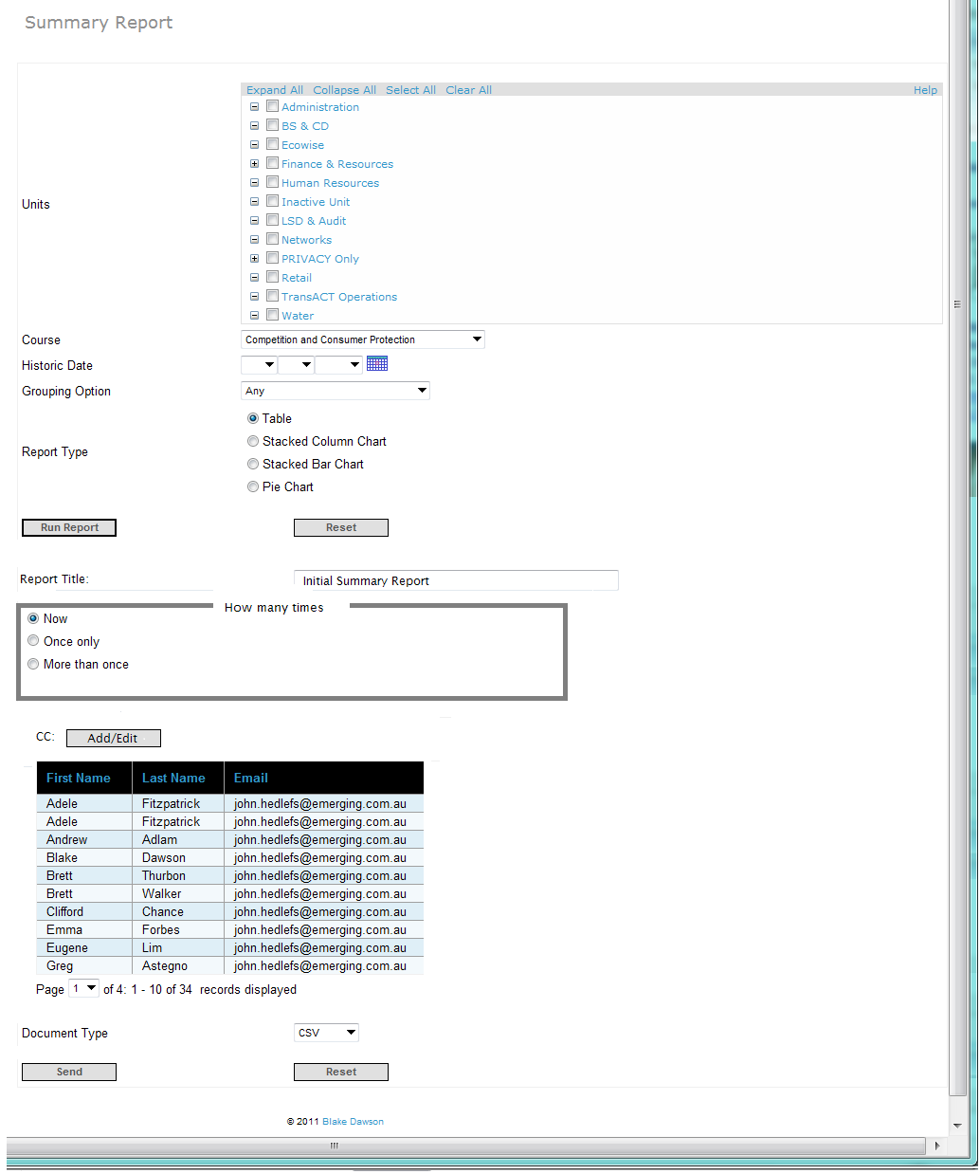

Figure 1 "Now" option for a Report with an "Effective Date" control

For a Report that normally has one date control (Effective or Historic date), when the user selects the “Now” option the Report will be delivered by Email EXACTLY as it would be rendered to the screen if he/she had pressed the “Run Report” button so the Date control behaves EXACTLY the same.

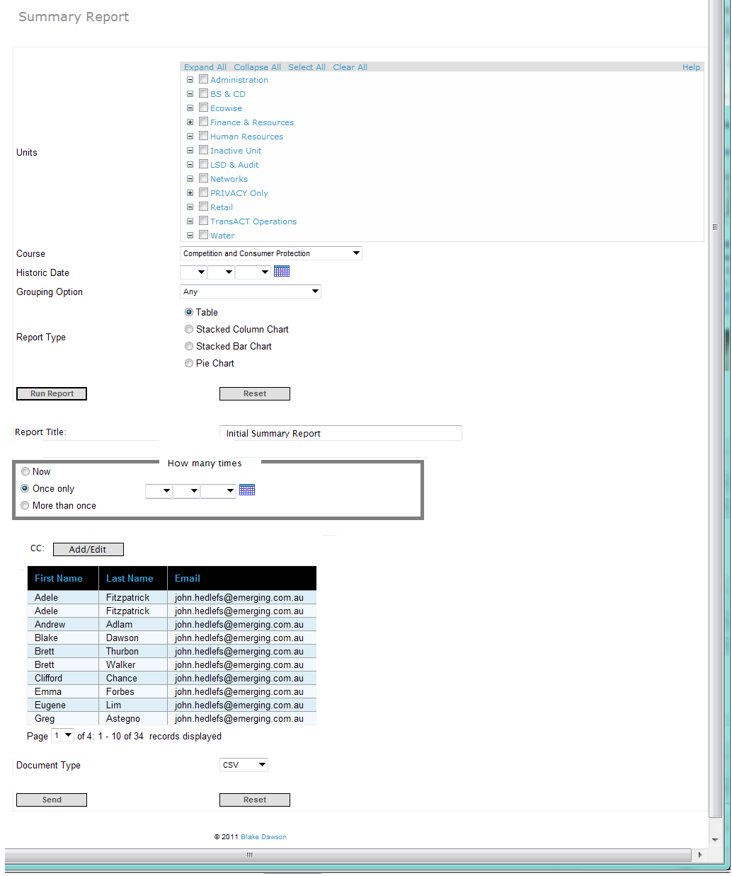

Figure 2 "Once Only" option for a Report with an "Effective Date"

For a Report that normally has one date control (Effective or Historic date), when the User selects the “Once Only” option the Report is sent on the date specified with an “Effective Date” of 23:59:59 on the night before the Report is delivered.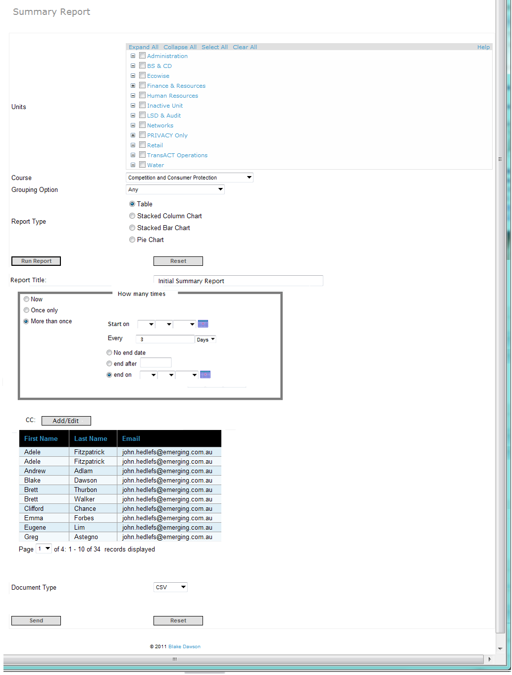

Figure 3 “More than once” option for a Report with an “Effective Date” control

For a Report that normally has one date control (Effective or Historic date), when the User selects the “More than Once” option the Report is sent at a fixed frequency with an “Effective Date” of 23:59:59 on the night before the Report is generated (delivered).

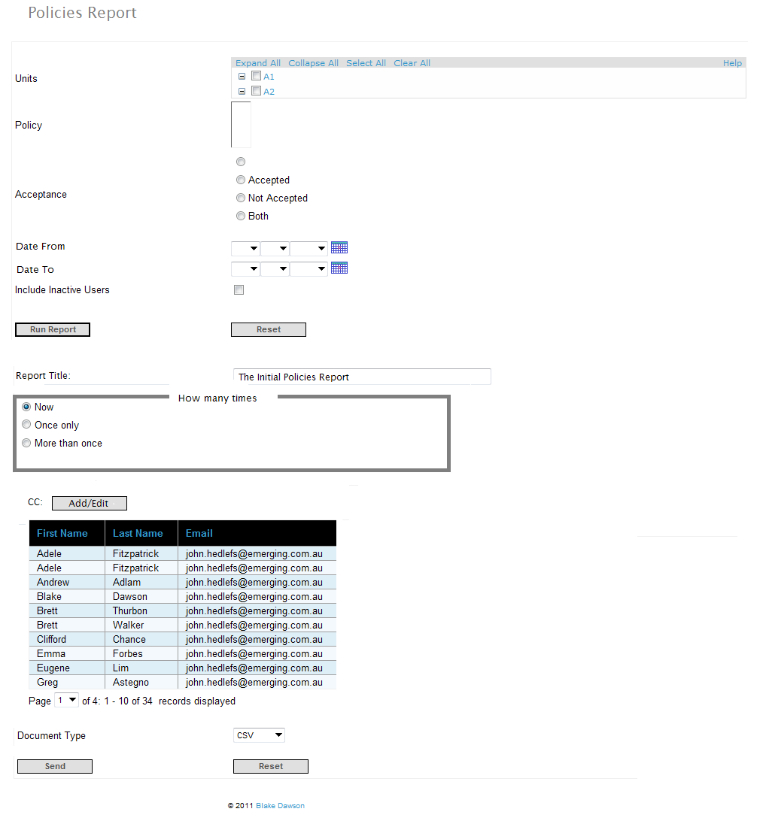

Figure 4 The "Now" option for a Report with From and To dates

For a Report that normally has two date controls, when the user selects the “Now” option the Report will be delivered by Email EXACTLY as it would be rendered to the screen if he/she had pressed the “Run Report” button so the Date controls behaves EXACTLY the same.

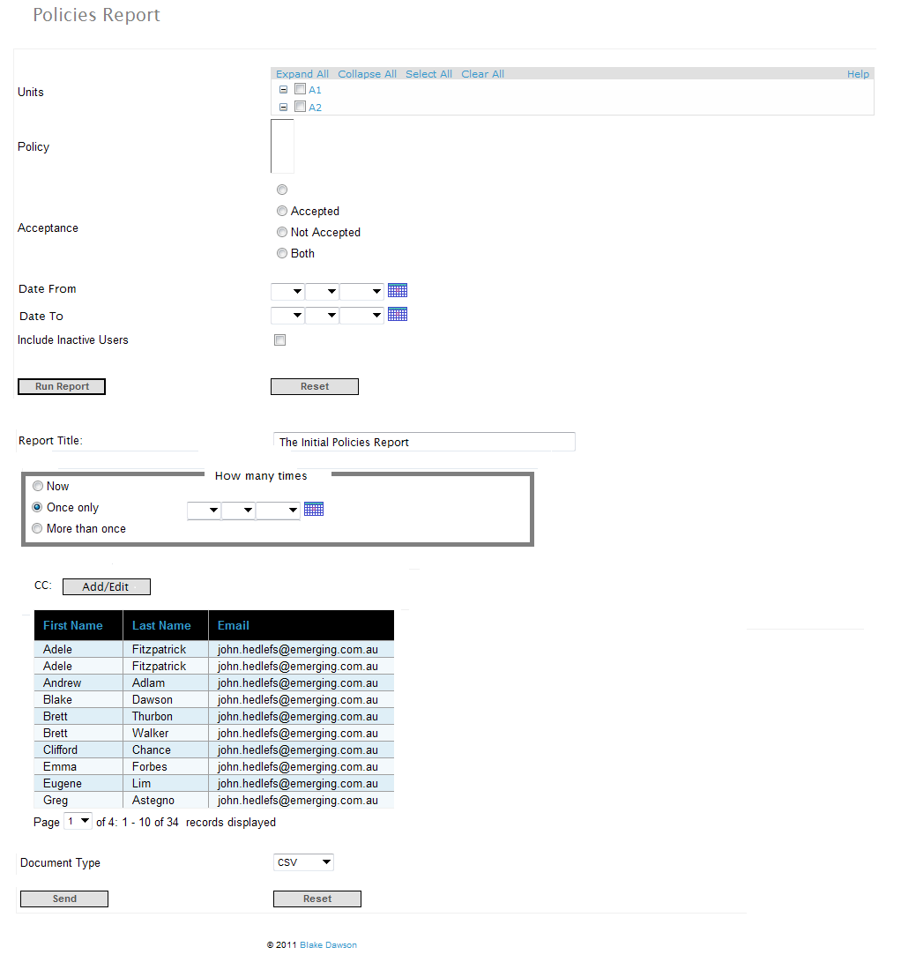

Figure 5 The "Once only" option for a Report with From and To date controls

For a Report that normally has two date controls, when the user selects the “Once only” option the Report will be delivered on the date selected.

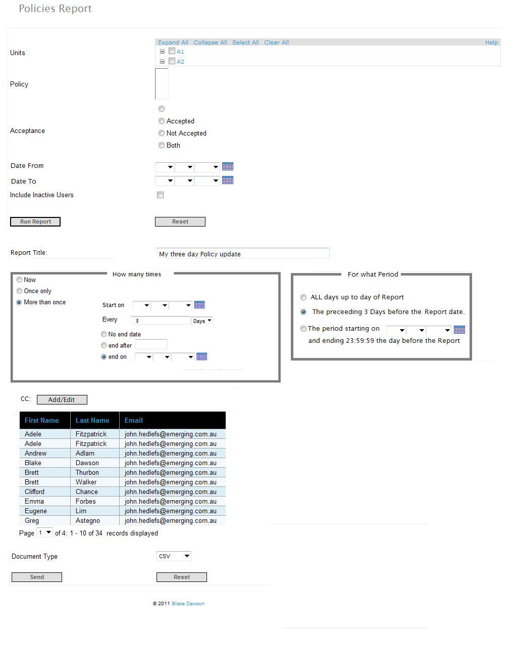

Figure 6 The "More than Once" option for a Report with From and To date controls

For a Report that normally has two date controls, when the user selects the “Once only” option the Report will be delivered repeatedly at the frequency specified in the “How Often” control. Three options are available for “More than Once - Two Date” Reports, these options are that the report will be generated for “All days”, For the period (same period as was specified in “How Often”) or “For the period from the specified date until 23:59:59 on the night before the Report is generated.

When a Report with “From Date” and “To Date” controls is setup to run on a schedule the actual “From Date” and “To Date” controls will disappear and instead the user will be presented with three options for specifying the date range that each of the Reports will cover. The three Radio Buttons (only one may be selected) are:

1. “All days up to the day of the Report”
2. “The preceding 3 days before the Report Date”
3. “The Period starting on a fixed date and ending on the day of the Report”.

**“All days up to the day of the Report**”

This will be the default selected option. The Report will be generated for a Period starting before any data was entered into SALT and ending at 23:59:59.9999 on the day before the Report is delivered. If the Report Queuing Service was disabled or unable to generate reports on a particular day then it will create the reports at the earliest possible moment with the periods that would have been used if the report was created on the correct day.

**“The preceding 3 days before the Report Date”**

The wording of this option will change when the user selects the interval between reports – for example when the user selects “Every” 6 months then this option will become “The preceding 6 months before the Report Date”. For an interval of 6 months the Report period will be from the 00:00:00 on the day 6 months before the day the report is delivered to 23:59:59.999 the day before the report is delivered. If the Report Queuing Service was disabled or unable to generate reports on a particular day then it will create the reports at the earliest possible moment with the periods that would have been used if the report was created on the correct day.

**“The Period starting on a fixed date and ending on the day of the Report.”**

The “Date From” is specified and all reports are created from 00:00:00 on that day. The last day of the Report will be 23:59:59.9999 on the day before the Report is delivered. If the Report Queuing Service was disabled or unable to generate reports on a particular day then it will create the reports at the earliest possible moment with the periods that would have been used if the report was created on the correct day.

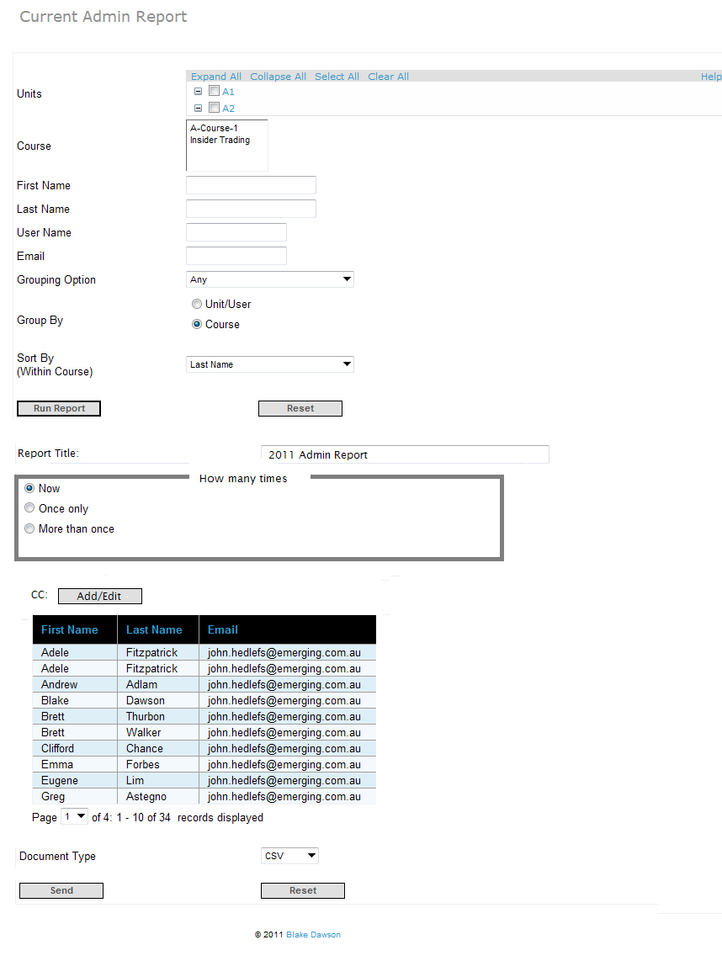

Figure 7 The "Now" option for a Report with no date controls

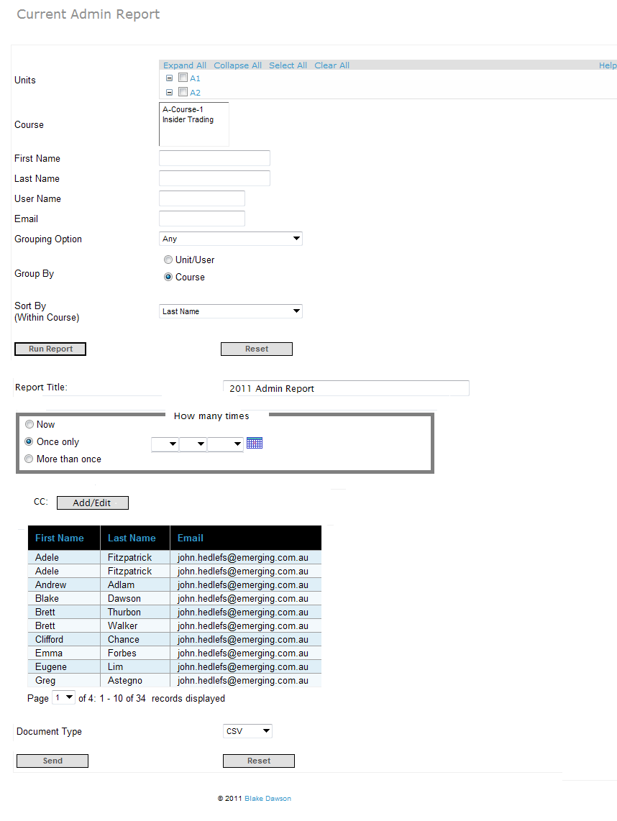

Figure 8 The "Once Only" option for a Report with no date controls

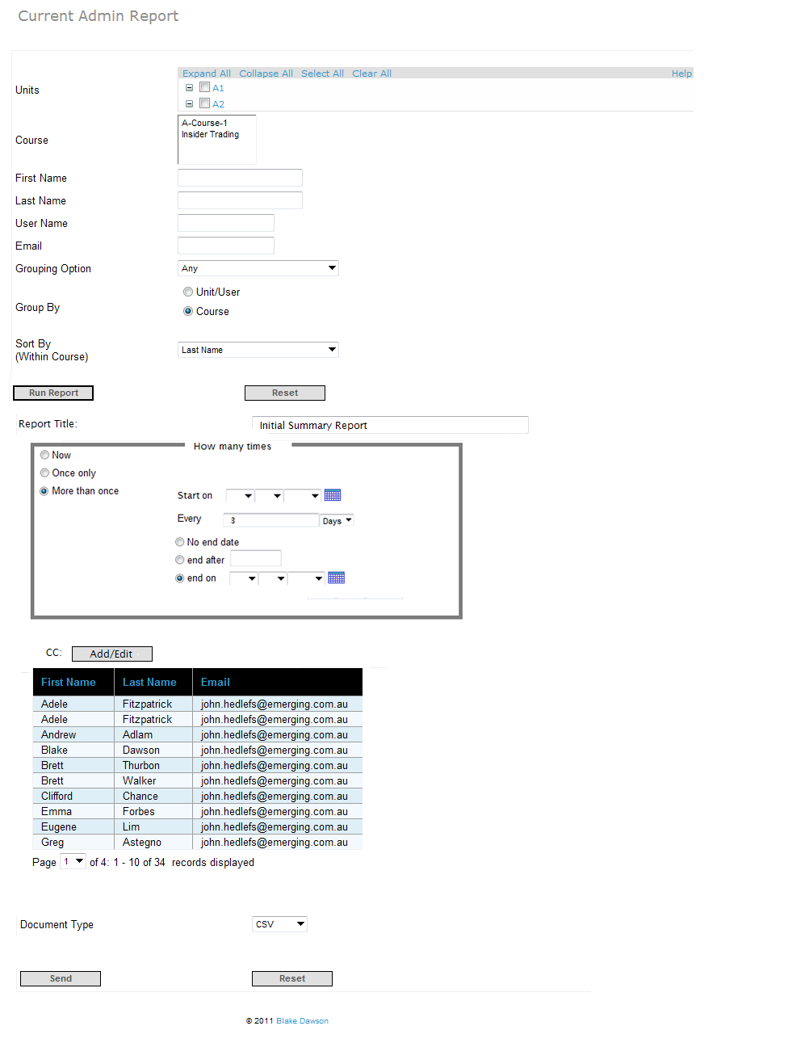

Figure 9 The "More than Once" option for Reports with no Date controls

The “No end date” option will be selected by default.

A Report schedule may have several CC: recipients, when a CC: recipient is inactive the other recipients will continue to receive the Reports via Email however the inactive Recipient/s will not receive the report.

A CC: label will be visible (just above the “Document type” control). There will be an “Add/Edit” button just to the right of this label as shown in screen below:

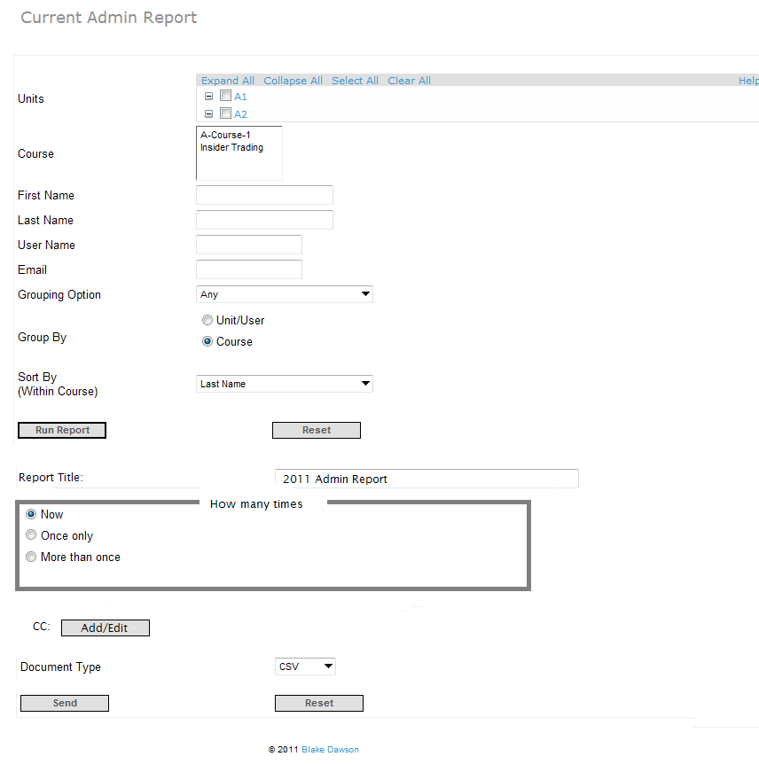

On clicking the “Add/Edit” button there will be pop up to select the recipients of the periodic report as shown in below screen. The Grid on the right initially contains the list of CC: recipients that was previously saved for this Report Schedule however the user may remove recipients from the grid on the right or add recipients from the grid on the Left (search grid) to the grid on the right. The admin can search for users with the “First Name” and/or “Last Name” fields. On clicking the “Find” button the search results will be populated in the grid below. The admin can select individual recipients by clicking on the “Add” link against the user or can select multiple users using the check boxes on the left and add them in bulk using the “Add Selected” button. On selecting the recipients from this grid, a new grid on the right will keep on being populated with the selected recipients. The admin can remove any of the selected recipients by clicking the individual “Remove” link or in bulk using the “Remove Selected” button below the grid. Once the admin has finished editing the recipients list in this pop up, he/she can click the “Save” button on the bottom of the pop up.

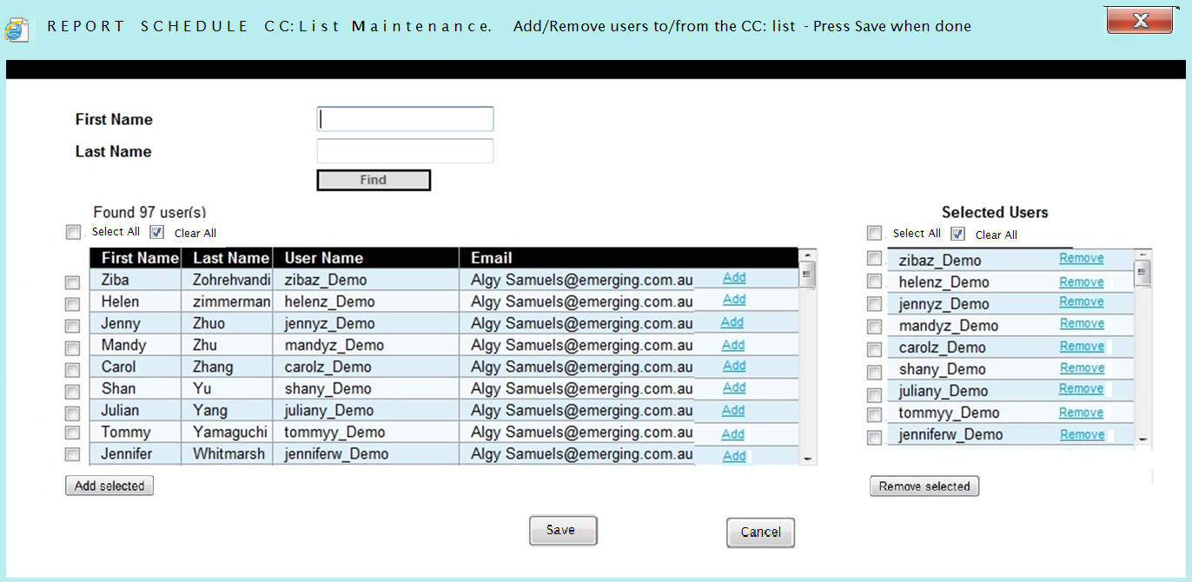

Note: There will be an (I) shown against the users who have become inactive.

If the user presses the “Cancel” button (or the “⌧”) then a popup containing the standard localized message (English version stating “All changes made on this form will be lost – Do you wish to continue”) and standard localised “OK” and “Cancel” buttons will appear, if the user select “OK” then both popups will close and all changes made since the popup appeared will be ignored (not persisted to the database) , if the user selects “Cancel” to cancelling their changes then they will be able to continue modifying their changes.

If the user presses the “Save” button the popup will close and all changes made by the user will be persisted to the database (if the CC: list for this report was modified by another user during the time that the popup was open the current users changes will be discarded and the standard localized message will be displayed to the user stating “Another user has modified the information contained on this page and your changes have been lost – Please open this screen again and modify the new information”) the CC: recipients list on the calling page will be reloaded (as shown on the next image) This CC: list will be a read only list. The list can be modified by clicking the “Add/Edit” button again.



Note: non-admin users can be added to the CC list

Note: On the day the message is actually sent the application should only send the Report to ACTIVE recipients.

Note: Where the Report owner is a Unit Administrator the Report will only be generated on units that the Unit Administrator currently has permission to administer. (Even if the Report is CC’d to someone with access to more Units (or less units in the case of a non-administrator).

# 2. Required on Period Report screen for Org Admins

Requirement: Change the functionality of the new “Periodic Report Delivery” screen so that it provides the following features:

2.1 For an Org Admin a list is shown of the periodic reports created by the Unit admins or org admins in the selected organisation. It will contain the following columns:

* Non localised Report Title entered by user in users character set (Heading Localised)
* Localised Report Type (Heading Localised)
* Localised Report Frequency (Heading Localised)
* Date Created dd mmm yyyy (Heading Localised)
* Report Starts on dd mmm yyyy (Heading Localised)
* Report Ends on dd mmm yyyy (Heading Localised)
* Next date when the report will run
* Report owner
* Admin type: This will show the admin type of report owner; U for unit admin and O for organisation admin
* Non-localised “Report Delivered to” (Heading Localised). This will either contain the name of the recipient if the report is delivered to single user, or it will contain the number of recipients if the report is delivered to more than 1 user
* Organisation and Unit Administrators will not see Report Schedules created by SALT admins.

2.2 Function to Delete/Remove selected reports

2.3 Function to Edit/Change a selected report (should return the org admin to the original screen where the report was created, with the current params/criteria filled in – do not want to be able to edit the selected report on the “Periodic Report Delivery” screen)

2.4 This list can be sorted in ascending or descending order (toggled) on a column by clicking the column name

2.5 There will be an “Export” button at the top right corner of the screen which will allow the user to export all of the data in the grid (shown in figure below). There will be a dropdown list to choose the format in which the admin wants the grid. The supported document types for export will be CSV, Microsoft Excel, and PDF.

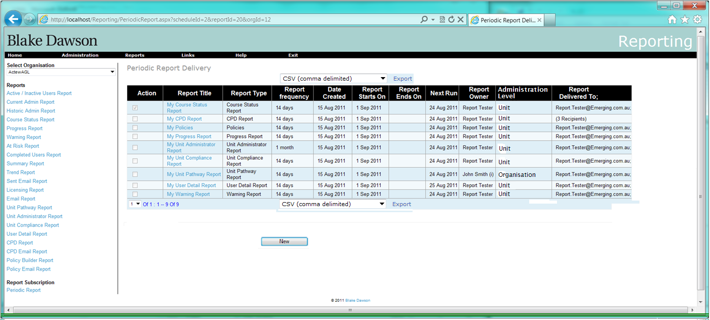

Unit administrators will not see reports created by Org administrators and therefore will not see the “Administration Level” column as shown in this screenshot:

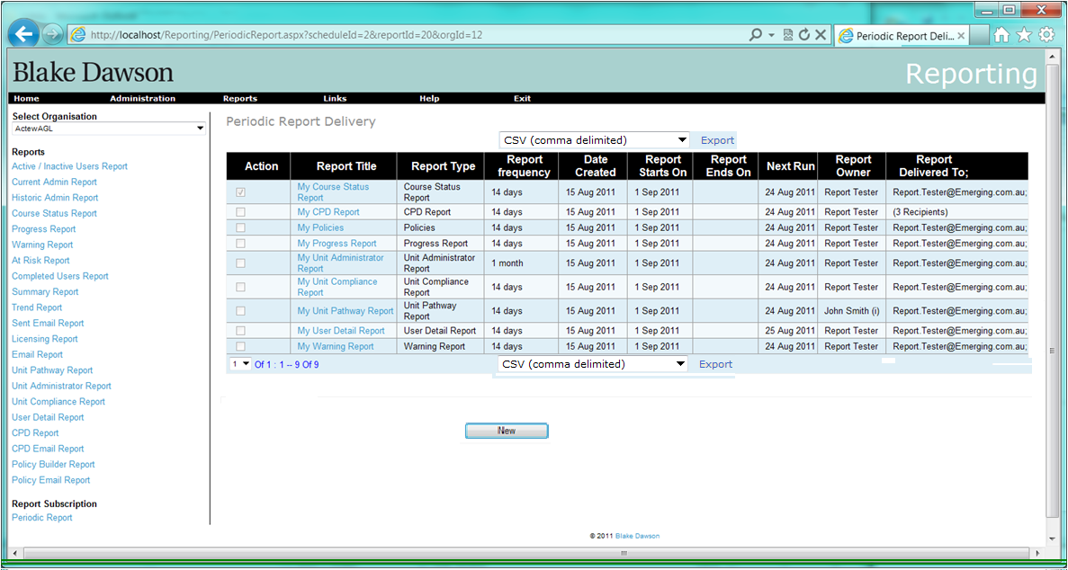

The User may select the format of the Export (look and feel as per similar export grids in the application without violating IP/copyright laws) from the dropdown list above or below the grid and pressing the “Export” link (these controls will be localised).

The PDF export file will contain a single long table that contains all of the rows in the grid (not just the visible rows) with the data in the fields in the same format as the rows appear in the grid (i.e. where a Report Schedule has 3 CC: recipients there will be a single row in the PDF for that Report Schedule and the “Report Delivered To” field will contain the text: “(3 Recipients)”. The PDF will be rendered without using the Organisations stylesheet.

The CSV export will contain a row for every recipient of every Report Schedule as shown below (note the addition of an extra column to identify multiple rows that belong to the same ReportSchedule, the number in this cell will be identical for each row of the same Report Schedule and different to rows for other report schedules even if the other Report Schedules have the same “Report Title” and “Report Type”):

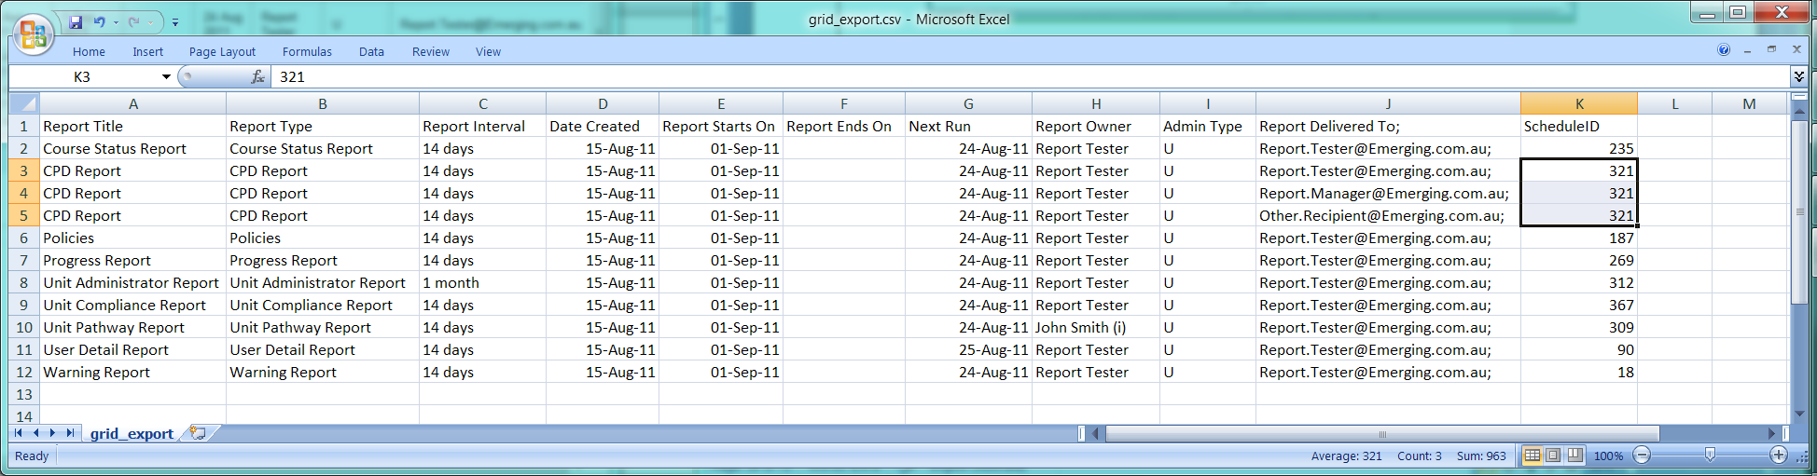

Note that Report Types and Report Titles may contain commas, single or double quotes which will be saved as per CSV standards. CSV files containing Unicode Report Titles and Report Types that contain characters that are not in the same locale as the computer reading the CSV may require some user intervention in order to open them properly.

"Report Title""",Report Type,Report Interval,Date Created,Report Starts On,Report Ends On,Next Run,Report Owner,Administration Level,Report Delivered To;,ScheduleID"today's Course Status Report, ",Course Status Report,14 days,15-Aug-11,01-Sep-11,,24-Aug-11,Report Tester,Unit,Report.Tester@Emerging.com.au;,235CPD Report,CPD Report,14 days,15-Aug-11,01-Sep-11,,24-Aug-11,Report Tester,Unit,Report.Tester@Emerging.com.au;,321CPD Report,CPD Report,14 days,15-Aug-11,01-Sep-11,,24-Aug-11,Report Tester,Unit,Report.Manager@Emerging.com.au;,321CPD Report,CPD Report,14 days,15-Aug-11,01-Sep-11,,24-Aug-11,Report Tester,Unit,Other.Recipient@Emerging.com.au;,321Policies,Policies,14 days,15-Aug-11,01-Sep-11,,24-Aug-11,Report Tester,Unit,Report.Tester@Emerging.com.au;,187課程狀態報表,Progress Report,14 days,15-Aug-11,01-Sep-11,,24-Aug-11,Report Tester,Unit,Report.Tester@Emerging.com.au;,269課程狀態報表,Unit Administrator Report,1 month,15-Aug-11,01-Sep-11,,24-Aug-11,Report Tester,Unit,Report.Tester@Emerging.com.au;,312Unit Compliance Report,Unit Compliance Report,14 days,15-Aug-11,01-Sep-11,,24-Aug-11,Report Tester,Unit,Report.Tester@Emerging.com.au;,367Unit Pathway Report,Unit Pathway Report,14 days,15-Aug-11,01-Sep-11,,24-Aug-11,John Smith (i),Organisation,Report.Tester@Emerging.com.au;,309User Detail Report,User Detail Report,14 days,15-Aug-11,01-Sep-11,,25-Aug-11,Report Tester,Unit,Report.Tester@Emerging.com.au;,90Warning Report,Warning Report,14 days,15-Aug-11,01-Sep-11,,24-Aug-11,Report Tester,Unit,Report.Tester@Emerging.com.au;,18

The Excel export will contain a row for every recipient of every Report Schedule as shown below (note the addition of an extra column to identify multiple rows that belong to the same ReportSchedule, the number in this cell will be identical for each row of the same Report Schedule and different to rows for other report schedules even if the other Report Schedules have the same “Report Title” and “Report Type”):

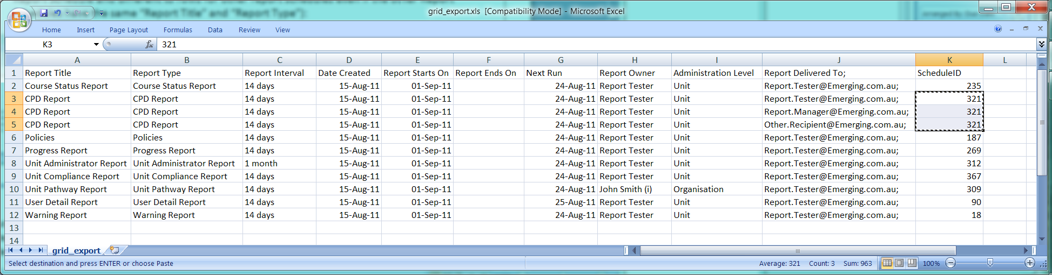

Period Report page (No Report Selected)

When a user selects a row the following buttons will appear:

1. Delete
2. Re-assign

Clicking on a “Report Title” will take the user to the same Report screen as they would see if they navigated through the Report menu (i.e. the screen they created the report from) however all of the fields on that Report screen will be populated with the information from the Report Schedule when that page opens.

Pressing the Delete button will produce a standard localized “Are you sure you want to delete this Report Schedule” dialog – pressing “ok” on that dialog will delete the Report Schedule (no screen will be available to view these deleted schedules, but the record will be kept in database).

Pressing the Re-assign button will produce a “Reassign Report Schedule to” popup as shown in this screenshot:

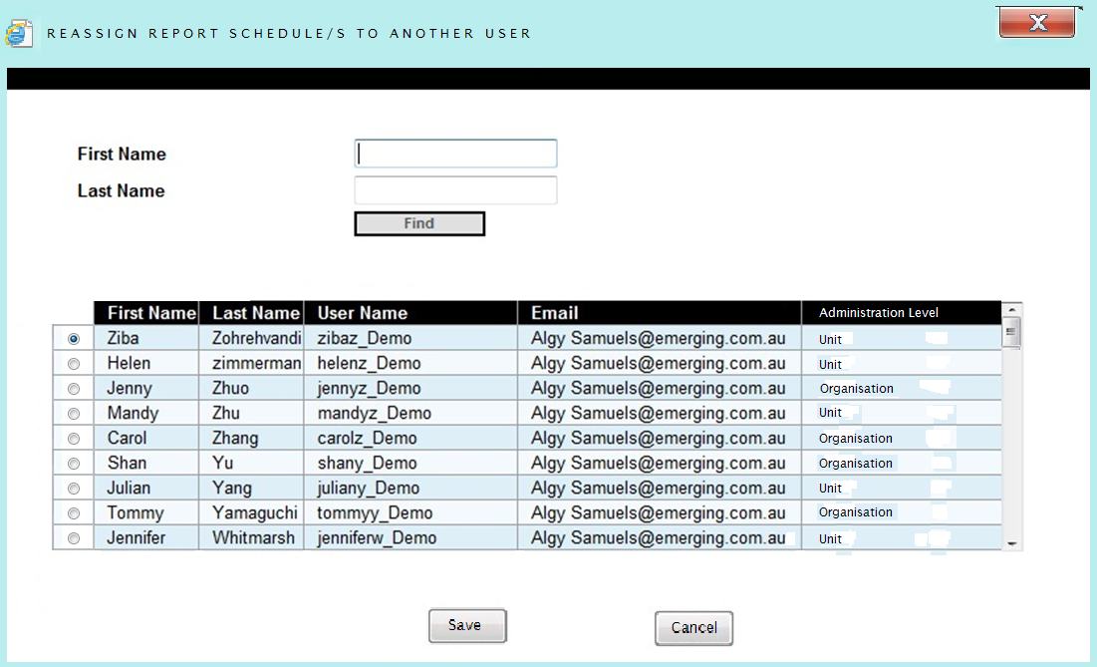

(This dialog is also used by other forms) The list of potential owners of the Report Schedule will only contain active Unit or Organisation Administrators. The user may only select a single person from the list and the list starts off with no users selected.

If a single person has been selected and the user presses “Save” then the popup will close and the Report will be reassigned to the selected person, if a person has not been selected when the user presses “Save” then a dialog will appear informing the user that *they must select a single person from the list (to become the owner of the Report Schedule) before pressing “Save”* and the popup will not close.

If the user presses the “Cancel” button (or the “⌧”) then a popup containing the standard localized message (English version stating “All changes made on this form will be lost – Do you wish to continue”) and standard localised “OK” and “Cancel” buttons will appear, if the user selects “OK” then both popups will close and all changes made since the popup appeared will be ignored (not persisted to the database) , if the user selects “Cancel” to cancelling their changes then they will be able to continue modifying their changes.

Pressing the new button (on the Periodic Report Delivery page) will cause a “Report Type” control to appear:

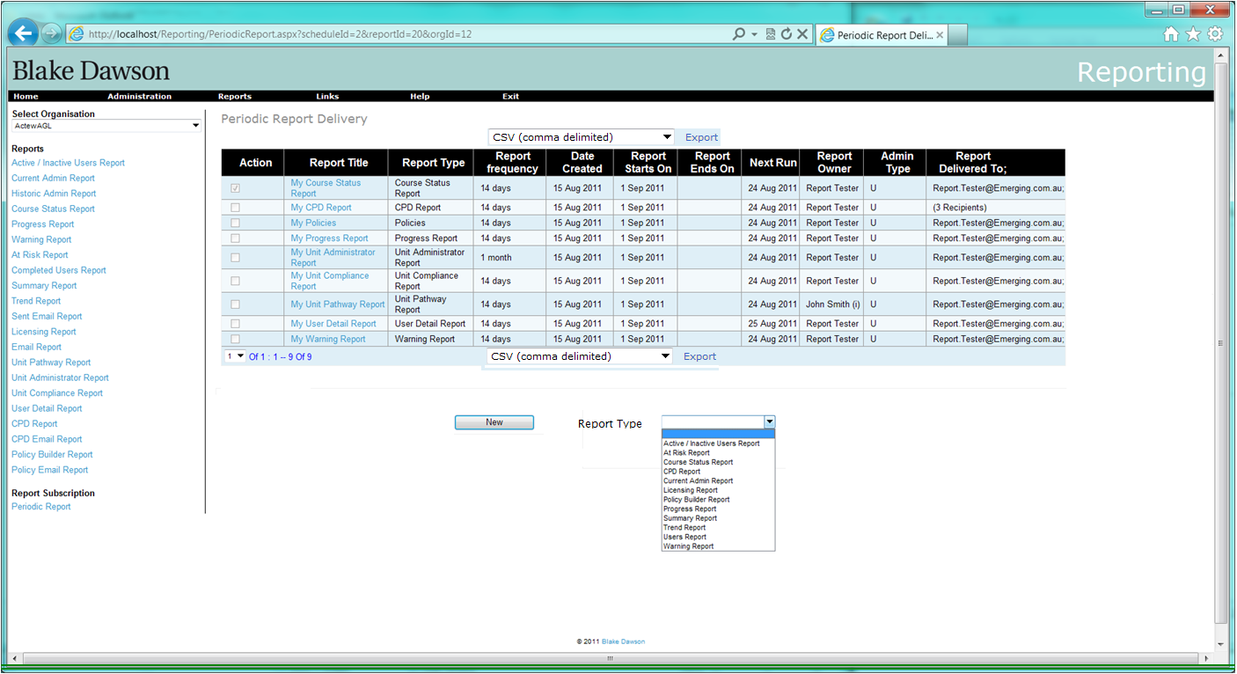

The “Report Type” control will be populated with the name of all Reports that the Administrator would have access to for this Organisation (in alphabetical order).

When the user selects a Report they will be taken to the Report Screen that they would see if they navigated through the Report menu.

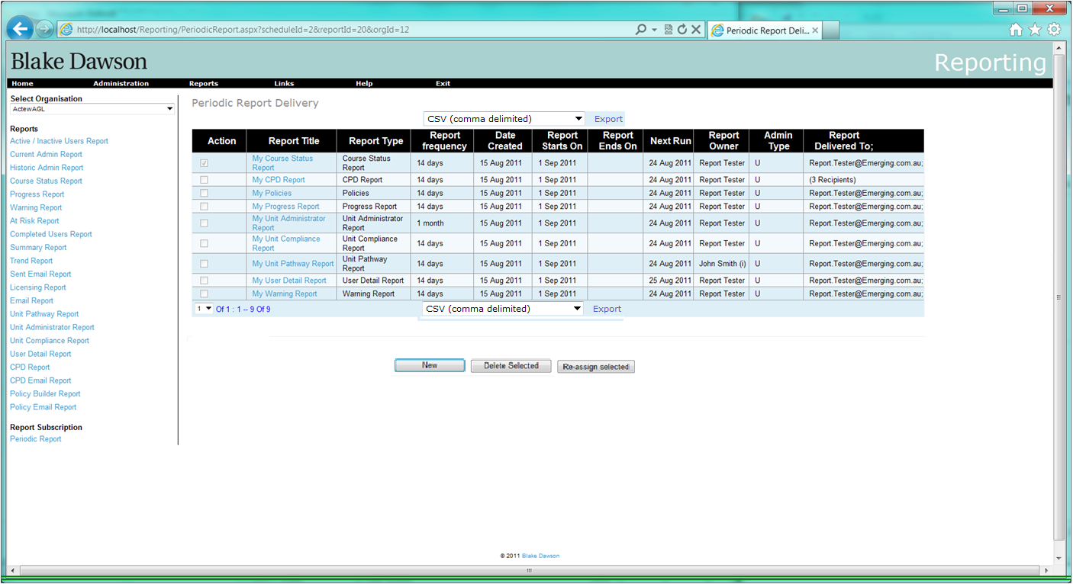

Figure 6 Periodic Report page for Org Admin (Report selected)

# 3 Additional fields required on Period Report screen for SALT Admins

Requirement: Change the functionality of the new “Periodic Report Delivery” screen so that it provides the following features:

3.1 For a SALT Admin a list of the periodic reports (filtered by the Organisation selected in the “Select Organisation” listbox in the top Left hand side of the application) created by all org admins (so the salt admin can “manage” periodic reports if an org admin leaves or changes) that contains the following columns:

* Non localised Report Title entered by user in users character set (Heading Localised)
* Localised Report Type (Heading Localised)
* Localised Report Frequency (Heading Localised)
* Date Created dd mmm yyyy (Heading Localised)
* Report Starts on dd mmm yyyy (Heading Localised)
* Report Ends on dd mmm yyyy (Heading Localised)
* Next date when the report will run
* Report owner
* Admin type: This will show the admin type of report owner; U for unit admin and O for organisation admin
* Non-localised “Report Delivered to” (Heading Localised). This will either contain the name of the recipient if the report is delivered to single user, or it will contain the number of recipients if the report is delivered to more than 1 user
* Organisation and Unit Administrators will not see Report Schedules created by SALT admins.

3.2 Function to Delete/Remove selected reports

3.3 Function to Edit/Change a selected report (should return the org admin to the original screen where the report was created, with the current params/criteria filled in – do not want to be able to edit the selected report on the “Periodic Report Delivery” screen)

3.4 This list can be sorted in ascending or descending order (toggled) on a column by clicking the column name

3.5 There will be an “Export” button at the top right corner of the screen which will allow to export the grid (shown in figure below). There will be a dropdown list to choose the format in which the admin wants the grid. The supported document types for export will be CSV, Microsoft Excel, and PDF.

3.6 Create new Reports delivered to the Salt Admin for the Organisation selected in the “Select Organisation” listbox in the top Left hand side of the application.

## Proposed screenshot:



Figure 7 SALT Admin Periodic Report page (No Report selected)

See section 2 for detail.

# 4. Delete/Re-assign Reports to another user when a User is made inactive.

**Requirement:**

The admin should be notified that the inactive user was either the owner of (in the case of an org admin) or a recipient of the following periodic reports.  The admin should then be given the following choice for each periodic report that relates to the inactive user:

* + Reassign the report to another user.  If the inactive user was the owner of the report, then the selected replacement user will become the new owner.  If the inactive user was just a recipient of the report, then the selected replacement user will now receive the report instead of the inactive user (other recipients remain unchanged).
  + Delete the schedule (a Record of deleted schedules will be kept however there will be no way to view deleted schedules at this time)

There are 7 (identified) circumstances when a user’s reports may be required to be transferred to another user or deleted:

* + 1. At the time a user is made inactive (archived) from the User Details screen.
    2. At the time that the users replacement is entered into the system (may be much later after the user is made inactive) from the New User screen.
    3. At the time that the users replacement is entered into the system (may be much later after the user is made inactive) from an import (CSV or XML).
    4. When a group of users are made inactive (archived) from the Archive Users screen.
    5. When a group of users are made inactive due to an import (CSV or XML)
    6. When a SALT administrator performs maintenance on reports (to inactive users) (for example Reports that were not transferred to the user’s replacement).
    7. At such other time that a SALT administrator needs to maintain an Organisations Scheduled Reports.

There are 5 webpages where an admin can modify users so that Periodic Report Schedules owned by the user can no longer be delivered:

* Make a single user inactive in the “User Details” screen
* Make bulk users inactive in the “Archive Users” screen
* Make bulk users inactive at import of users
* Revoke an Organisation admin (Remove Organisation rights of a user)
* Revoke an Unit admin
  1. On the “User Details” screen, when the admin unchecks the “User Active” checkbox and clicks “Save” button, a new screen is displayed asking if periodic reports owned by this user should be modified.

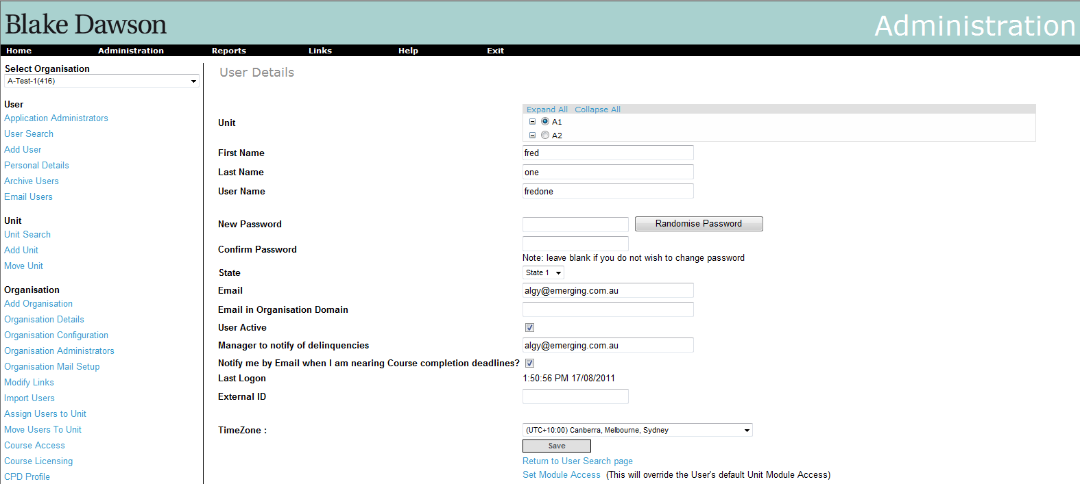

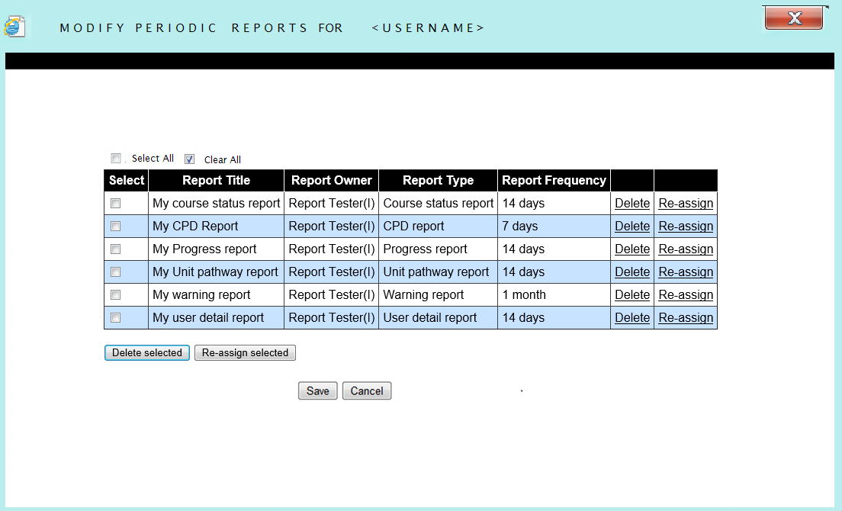

A grid will be displayed on this page, as shown in the figure above, showing the periodic reports that are owned by this user. There will be columns showing “Report Title”, “Report Owner”, “Report Type”, and “Report frequency”. Apart from these, there will be “Delete” and “Re-assign” buttons against each report. The admin can deleted the report or reassign the report using these buttons respectively. The admin can also select multiple reports and delete or re-assign them all by using the “Delete selected” or “Re-assign selected” buttons at the bottom of the table respectively. Clicking on the Grid Headings will cause the Grid to be ordered by that field (clicking on the same heading twice will cause the sort order to toggle between ascending and descending). The Default sort order is by Report Owners Lastname, Report Owners Firstname, Report Type, Report Title.

The “Report Title” of each of the reports will be a hyperlink which will navigate to the “Edit Periodic Report” screen.

At the bottom of the screen there are buttons to save these changes or cancel the changes made and return to the “User Search” page. If the user attempts to “Save” and return to the calling form without re-assigning all Reports they will be warned that some Report schedules will stop producing Reports because the Report Schedules are owned by inactive users, the user can elect to return or stay on this form and finish editing. Pressing “Cancel” will result in a dialog appearing that warns that all changes will be lost, the user will be presented with “OK” and “Cancel” buttons. If the user presses the “Cancel” button then the popup will remain open, if the user presses ”OK” then all changes will be lost, the popups will close and control will return to the calling form.

* 1. On bulk archiving the users, the following screen will be shown to the admin:

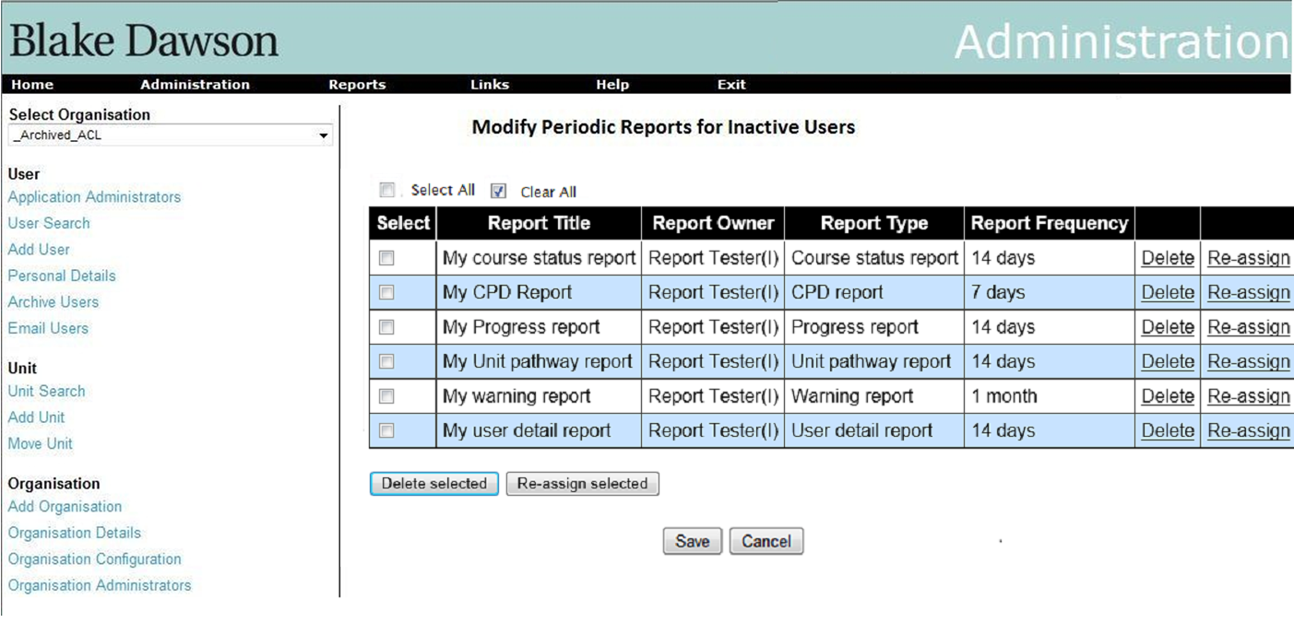

The functionality of these tables will be the same as explained in section 4.1. The only difference in this case will be that it will contain periodic reports for all the users that are archived.

* 1. For bulk import of users too, the same screens in section 4.2 will be shown. However, in this case the grid will contain the inactive users from the imported users list.
  2. An Organisation Admin can be removed from Organisation Admin list i.e. the user’s org admin privileges are revoked from the screen shown below.

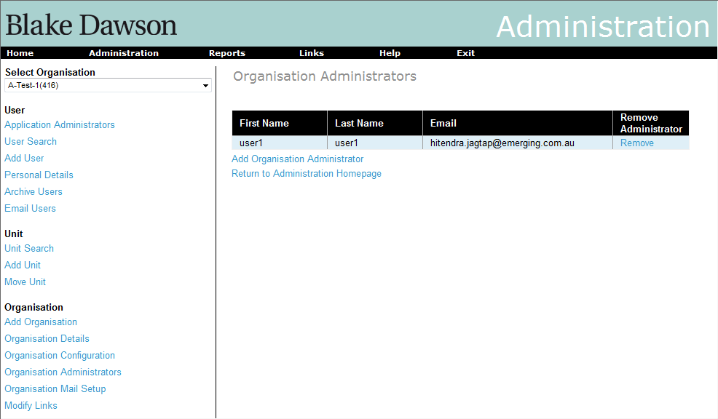

On clicking the “Remove” link in the above screen, the User will be removed as Organisation admin and a screen will pop up showing the periodic reports owned by the user and the periodic reports for which the User is a recipient. The same actions as mentioned in section 4.1 are applicable here (see the screenshot below).

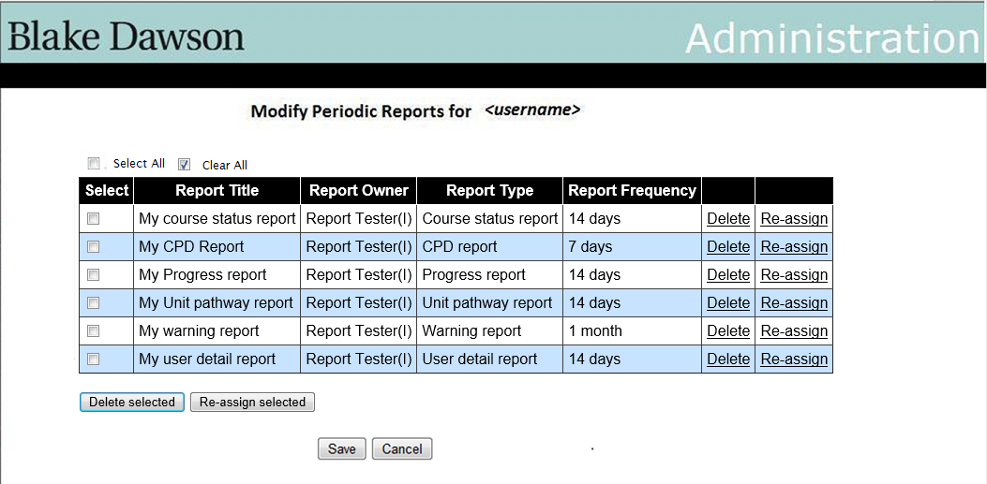

4.5 A Unit Admin can be removed from Unit Admin list i.e. the user’s Unit admin privileges are revoked from the screen shown below.

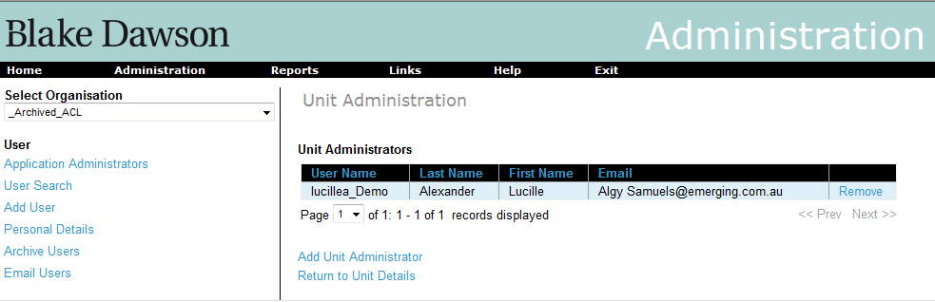

On clicking the “Remove” link in the above screen, the User will be removed as Unit admin and a screen will pop up showing the periodic reports owned by the user and the periodic reports for which the User is a recipient. The same actions as mentioned in section 4.1 are applicable here (see the screenshot below).



# 5. Allow import files to update existing users and Additional fields in import files

Requirement: Provide a bulk update feature for user imports that will allow org admins to change user values en masse without affecting existing values (i.e. update the manager’s email address for a group of users, but, don’t change anyone’s password, or give a group of users new email addresses, but, don’t change their passwords, or give a group of user new passwords, but, don’t update their email addresses, etc.).

5.1 New Fields:

* Unit Administrator
* Organisation Administrator
* Manager notification
* Manager

All of these new fields, with the exception of “Manager Notification”, specify whether delinquencies of that user be alerted by email to these roles respectively. The “Manager Notification” field contains the email id of the manager to notify.

Following is the format of CSV file that will be supported. Each of the columns here represents text that will be separated with a comma. The column names are not required to be part of the file. The columns that are greyed out are the new additions.

|  |  |  |  |  |  |  |  |  |  |
| --- | --- | --- | --- | --- | --- | --- | --- | --- | --- |
| **username** | **password** | **firstname** | **surname** | **email** | **external ID** | **unit ID** | **archive** | **group by** | **value** |
| bdawson | compliance | Blake | Dawson | [blake.dawson@bdw.com](mailto:blake.dawson@bdw.com) | 225 | 100 | 0 | Job Role | Administrator |
| bdawson |  | Blake | Dawson | |  | | --- | | blake.dawson@bdw.com | |  | 101 | 0 |  |  |

|  |  |  |  |
| --- | --- | --- | --- |
| **Unit Administrator** | **Org Administrator** | **Manager Notification** | **Manager** |
| Yes / No | Yes / No | Yes / No | =if(="Yes","Enteremailaddress",BLANK) |
| Yes / No | Yes / No | Yes / No | test.manager@testsite.com |

These fields will indicate whether the respective administrators should get the alert emails or not.

The format of the XML files will be:

<?xml version="1.0" encoding="Windows-1252"?><BDWUserUpload xmlns="<http://salt.bdw.com/schemas/v3/0>">

  <User Username="fred1" Password="bbbbbbbb" Firstname="fred" Lastname="0" Email="[fred1@emerging.com.au](mailto:fred1@emerging.com.au)" ExternalID="" UnitID="" Archive="1"     NotifyUnitAdmin="N" NotifyOrgAdmin="N" ManagerNotification="Y" ManagerToNotify="[joe.blow@BlowsBloggs.com](mailto:joe.blow@BlowsBloggs.com)">

    <CustomClassifications>

      <CustomClassification Name="State" Option="State 1" />

    </CustomClassifications>

  </User>

<User Username="fred2" Password="bbbbbbbb" Firstname="fred" Lastname="0" Email="[fred2@emerging.com.au](mailto:fred2@emerging.com.au)" ExternalID="" UnitID="" Archive="2">

<CustomClassifications>

<CustomClassification Name="State" Option="State 1" />

</CustomClassifications>

</User>

</BDWUserUpload>

* The four new fields will not be compulsory in CSV files.
* The four new fields will not be compulsory in XML files.
* A CSV file containing a mixture of rows where some rows contain the new fields and some rows do not contain the new fields will be considered valid.
* An XML file containing a number of records where some records contain the new fields and some records do not contain the new fields will be considered valid.
* A row in a CSV file that does not contain the four new fields and that results in an update will not affect the four new fields for that user.
* A record in an XML file that does not contain the four new fields and that results in an update will not affect the four new fields for that user.
* A row in a CSV file that does not contain the four new fields and that results in a new user being created will use default values for the four new fields for that user.
* A record in an XML file that does not contain the four new fields and that results in a new user being created will use default values for the four new fields for that user.
* The suggested Default values to be used for the four new fields are:
* NotifyUnitAdmin="N"
* NotifyOrgAdmin="N"
* ManagerNotification="N"
* ManagerToNotify=""

The preview will show the new fields for as per the screenshot:

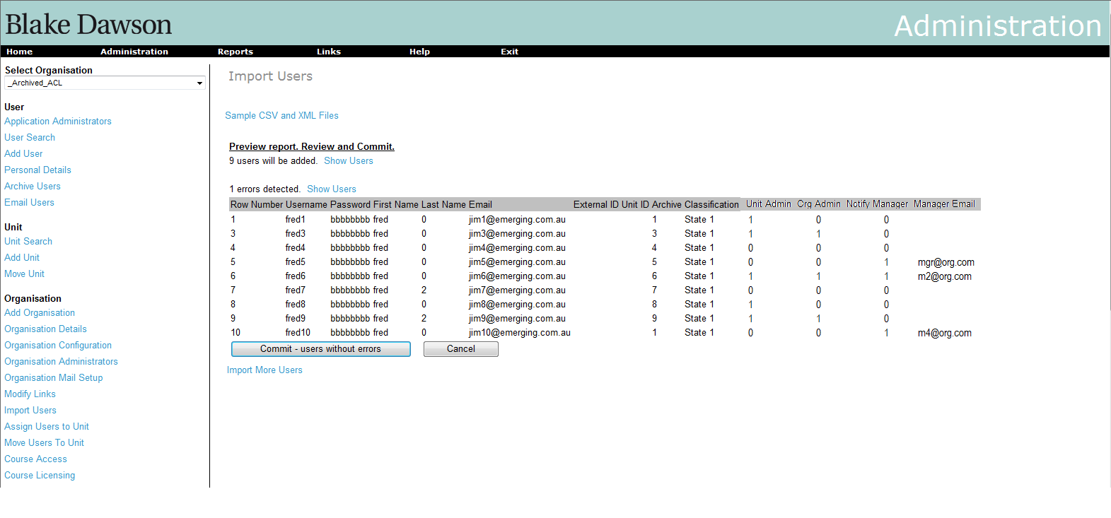

These new fields will also be added to the User Details screen. Only administrators will be able to see these new fields. Here is the screenshot of the modified User Details screen:

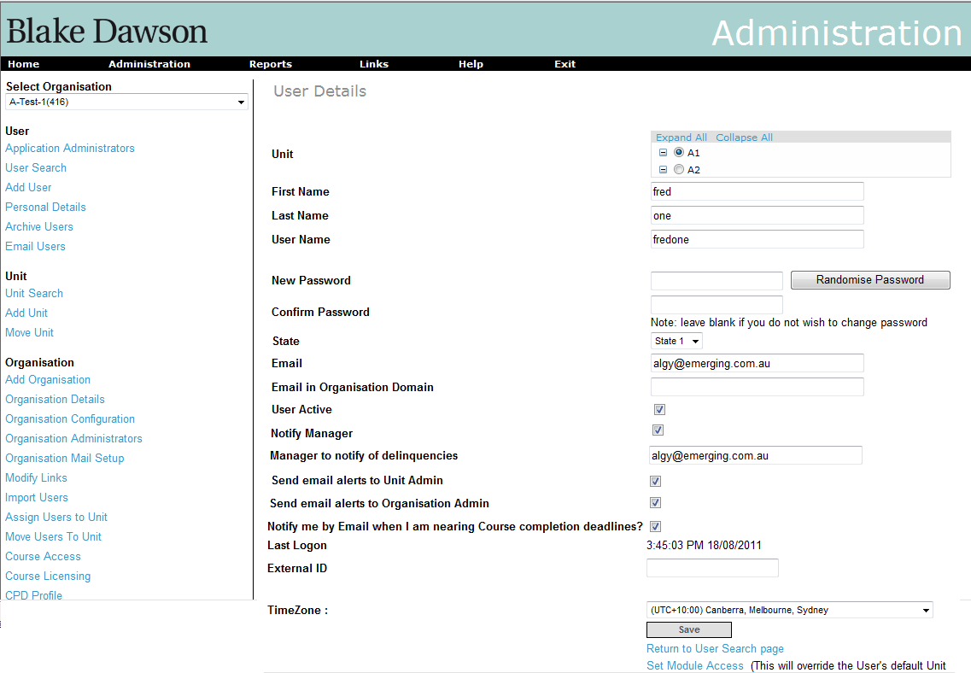

## 5.2 Behaviour of “Update Imports”

The functionality of the currently supported columns will remain the same as it is currently in SALT.

The additional functionalities will be as follows:

Currently only new users identified by the “unique field” can be added. However, now updating of existing users will also be supported. It is proposed that

1. If a column is empty for an existing user then the value of this field will be maintained as it is currently there in the system and will not be overwritten.
2. If there is a value in a column for an existing user then the value of that field currently there in the system will be overwritten with the new value.
3. If there is a user in the imported file, which is not currently there in the system, then a new user will be created with the values of the fields as there in the imported file.
4. If there is a user in the imported file, which is currently there in the system, then the values of the fields for that user will be updated with the new values in the corresponding columns in the imported file.

When a there is only a single carot (^) entered in a cell when editing the CSV file with excel the contents of the field will be deleted. The only fields that can be deleted while importing users are “External Id” “Group by”, “Value”, and “Manager”. If carot (^) is used in other fields then treat it as no update to that field.

In the preview screen, Instead of showing only the users that will be added and users that have errors in the import file, the users that will be updated will also be shown. The fields that are updated will be shown in a different colour. Below is a screenshot:

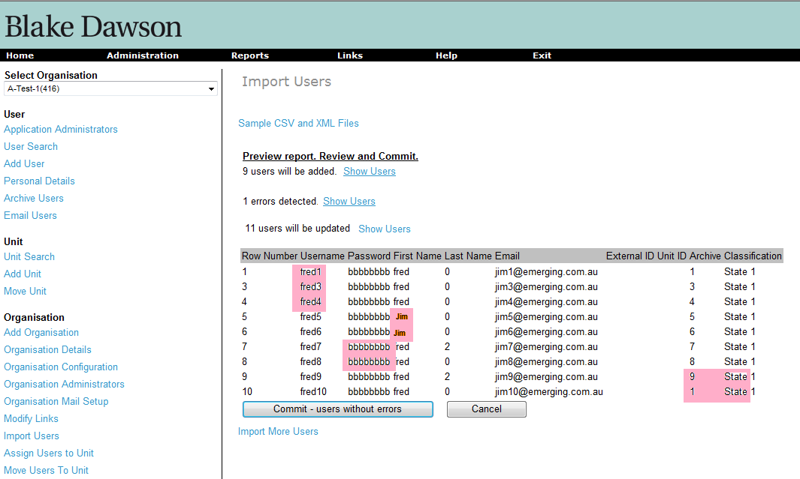

# 6. Modifications to “My Training” page

## Requirement:

The current “My Training” page shows the list of courses that are assigned to the user. It shows status i.e. whether the course has not been attempted, or is in progress, or has been completed. Please see the screenshot below:

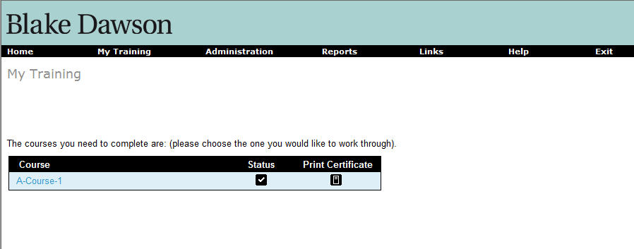

On clicking on the course the list of associated modules are displayed. The status of the lessons and quizzes in the modules are displayed as icons as shown below.

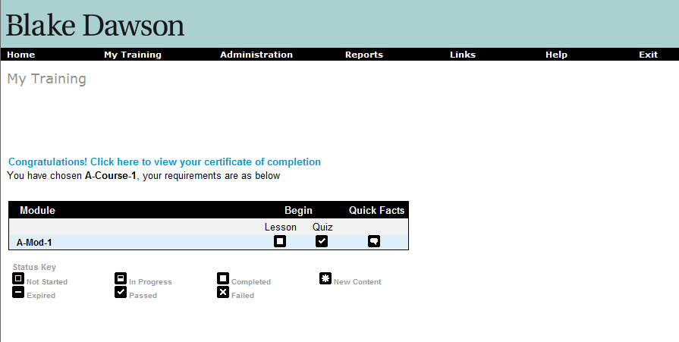

## Proposed modifications screens:

The “My Training” page with courses may show 2 more columns as shown in below screenshot. The 2 columns will appear by default for all Organisations but may be hidden by changing configuration values in the “Organisation Details” screen. The “Due Date” column shows the date when the user is Overdue or the number of days until it becomes overdue. The colour of the text will be red and BOLD if the due date has passed. The “Last completion date” column shows the last date when the course was completed by the user. It is assumed that it will be useful to know when the certification for the course is expiring.

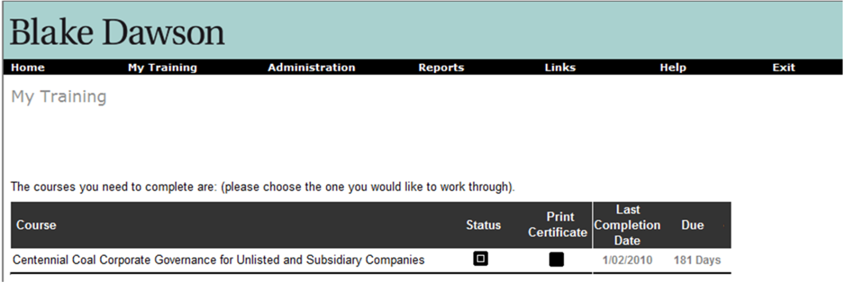

The “Modules” screen may have 2 more columns for the modules as shown below. The 2 columns will appear by default for all Organisations but may be hidden by changing configuration values in the “Organisation Details” screen (the same checkbox hides the 2 new columns on both “My Training” screens). The “Last pass date” will show the date when the user has last completed the module and passed the quiz. The “Quiz due” column will show the due date for passing the quiz or the number of days before it expires. The colour of the text will be red and BOLD if the due date is in the past.

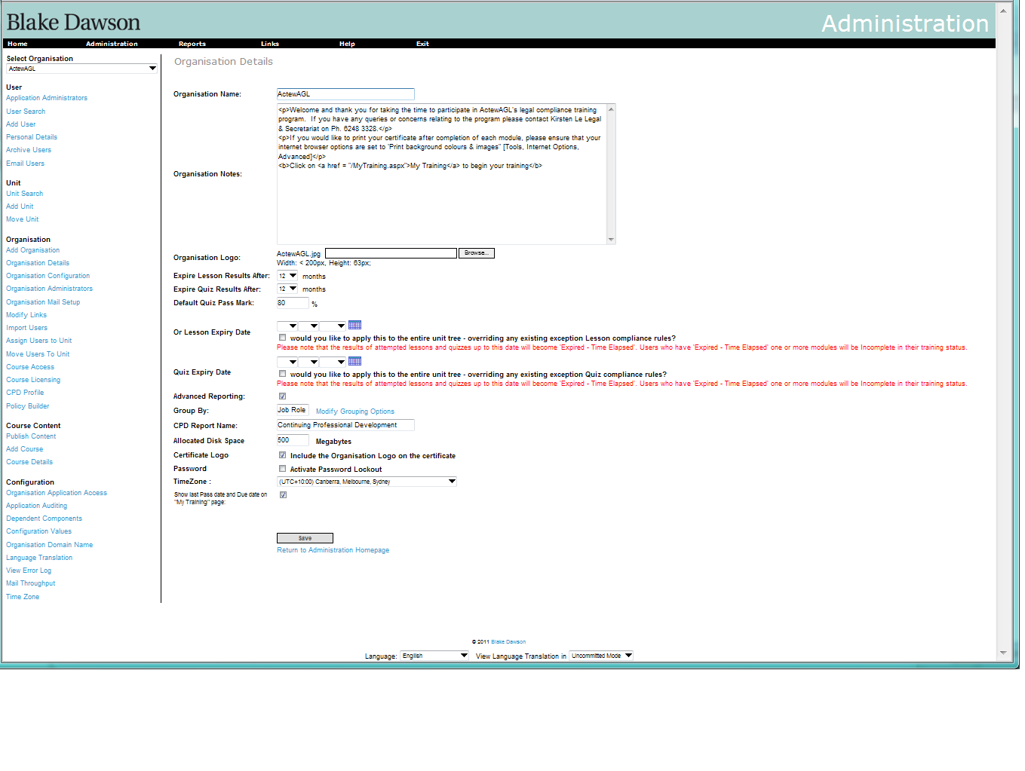

The new flag to hide/show the two new columns.

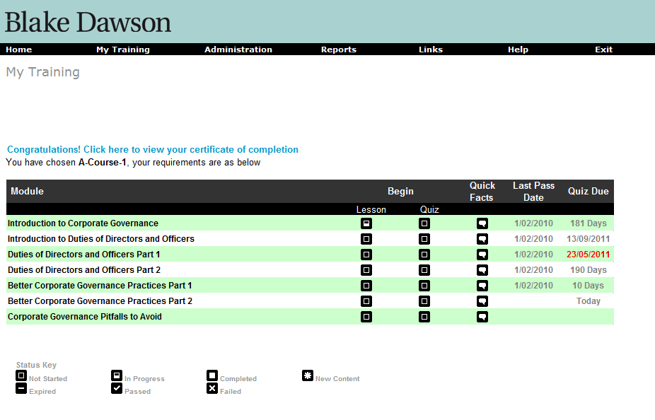

# 7. Provide a Rich Text editor on the existing “Org Config” screen

Requirement: Provide a Rich Text editor for each email template on the existing “Org Config” screen that allows org admins to define HTML email templates rather than just plain text email templates.

## Proposed Screens:

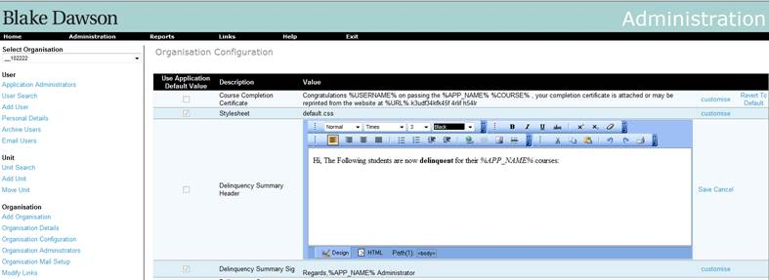

Figure 9 Organisation Config Screen (Editing - i.e editor visible)

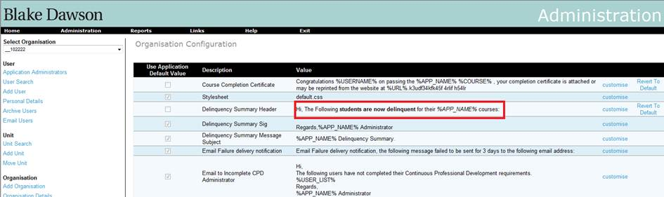

Figure 10 Organisation Config Screen (Not editing)

# Requirements

To add the ‘customise option’ for message that has already been customized:

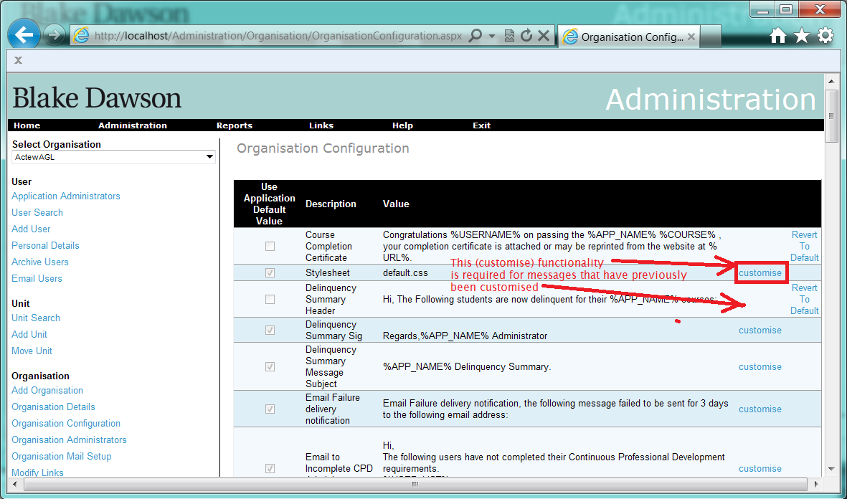

# 8. Ability to disable manager notifications at course level and to produce summaries or individual notifications.

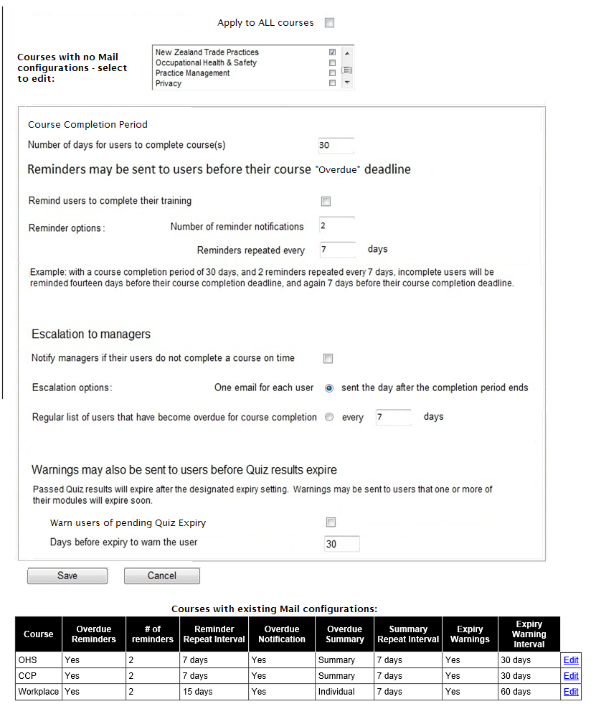

For each course in the Organisation the Administrator may define how the Overdue Emails will behave. The Manager may choose to have

* “Nearly Overdue” reminders emails sent?
* # of “Nearly Overdue” reminders
* “Nearly Overdue” reminder interval
* Overdue (escalation) messages sent?
* A summary of all overdue users OR a separate email for each user.
* Summary/Individual Email sent every N days
* Send Quiz Expiry Warnings?
* Quiz expiry warning interval – N days.

The grid at the top lists all courses that have not been setup yet and allows the user to select multiple courses to save the displayed settings to.

The grid at the bottom lists all courses that have previously been configured, pressing the “Edit” link will populate the form with the saved values for that course and allow the user to edit and save the configuration for that course. It is possible for a user to edit the configuration for an existing course and save the configuration values to some or all of the courses that were not previously configured.

When a Course is not configured the Mail Services will treat that course as if it was configured to not send emails of any kind and to never consider courses as “Overdue”. When editing a course that has not previously been configured the controls will initially be populated with these settings:

* “Nearly Overdue” reminders emails sent - YES
* # of “Nearly Overdue” reminders - 1
* “Nearly Overdue” reminder interval – 14 days
* Overdue (escalation) messages sent? - YES
* A summary of all overdue users OR a separate email for each user - Summary
* Summary/Individual Email sent every 7 days
* Send Quiz Expiry Warnings - YES
* Quiz expiry warning interval – 14 days.

TODO – determine if the “Course Completion Period” can be setup for each course or at the organisation level only!

TODO – determine if the “Apply to all courses” checkbox saves to all previously un-configured Course or all Courses (including previously configured Courses).

## 8.1 Ability to disable manager notifications

The Mail Queuing service will not create Overdue summaries for courses in the Organisation flagged as “no Overdue emails sent” however the service will set flags such that if the “no Overdue emails sent” is unset in the future the manager will not receive emails for the period when “no Overdue emails sent” was set.

## 8.2 Ability to modify notification options for each course

The default options will be for no notification for a course so the user must modify the “Course Expiry” Mail options for a course before managers will receive notifications for that course.

A separate email will always be sent for every course.

## 8.3 Ability to produce summaries or individual notifications.

The services will be modified to allow individual emails to be sent.

## Ability to produce summaries at frequencies other than one day.

# 9. Provide a feature that allows admins to temporarily stop emails.

Sometimes the number of emails being sent may be too much for the system to handle or one of the Mail services may be unable to process an unexpected error condition resulting in it repeatedly resending an Email. In such scenarios, the organisation admins and the SALT admin should be able to temporarily disable all emails either for the organisation or (in the case of a SALT admin) for the **entire** site.  This should not just stop the mail sending service, thereby allowing emails to queue up whilst it’s disabled, which may result in a mail storm when the sending service is re-enabled – it should delete all existing emails that are currently queued .

When an ORG admin requires emails to be stopped for an Organisation he/she can press a button and the Website will flag the Services to stop sendingEmails for that Organisation.

If one of the Mail Services is unable to process an unexpected error condition resulting in it repeatedly resending an Email it may be necessary to restart or stop it (because it may not respond to the changed flags) so when the SALT admin stops emails for the entire website the Mail Sending Service will be fagged to stop and the website will also attempt to directly stop the service on whatever server it is running on. At the time that the Mail Sending Service is stopped (but not when it is started) the other two services should be restarted. This will apply only to the emails sent via “Mail sending service” (not ad hoc emails sent directly from Webpages).

When either of the three services start and connect to the database for a SALT website they should save their ServiceName to tblAppConfig so the code behind the “Stop Email” button can locate the correct services to stop/restart for this website.

The website may be on a different server to the Mail Sending Service which can create problems in granting permission to the account that the website runs under to stop services on the server that is running the mail service (if both are on same Domain this should not be a problem).

Even when a SALT admin has the “STOP all Emails” button pressed the following reports will still deliver Emails:

* “Email Report”
* “CPD Email Report”
* “Policy Email Report”

See following pages for more detail.

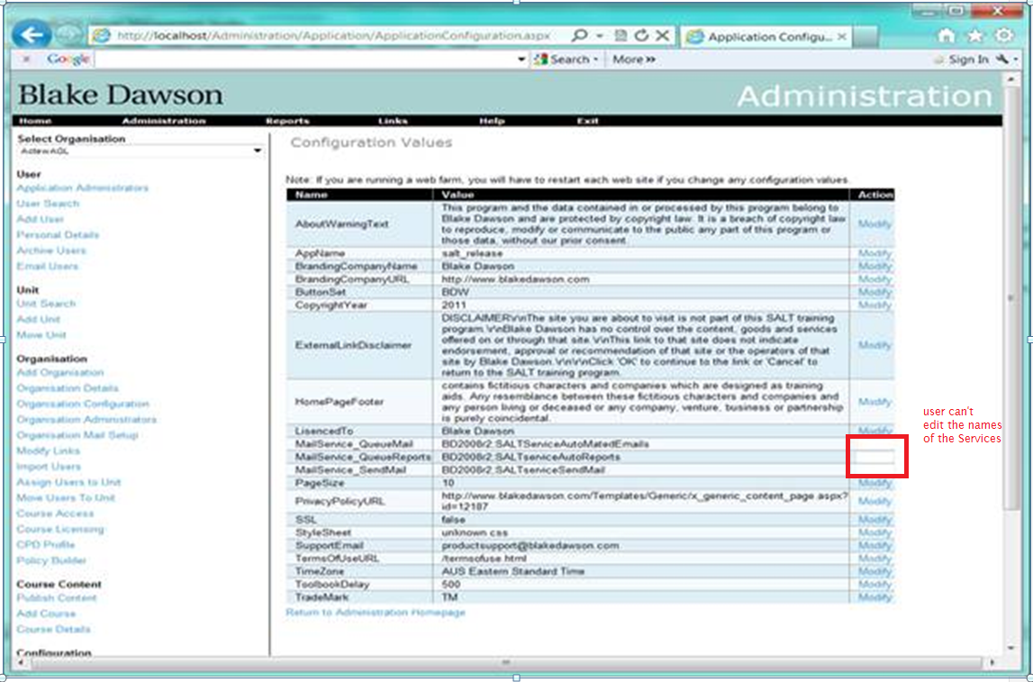

It will be the responsibility of the Person installing the Website to ensure that the Account that the Website runs under is granted start/stop/Interrogate permissions for the mail sending service and restart permissions for the Mail queuing service and the report queuing service on the servers on which they run and that firewalls or network configs between the Webserver and the server on which the services run do not block “start/stop service requests”.

To enable the “Stop Email” functionality, there will be a button on the “Organisation Mail Setup” screen for the Organisation admin to stop emails for their organisation. The screenshot for this is shown below:

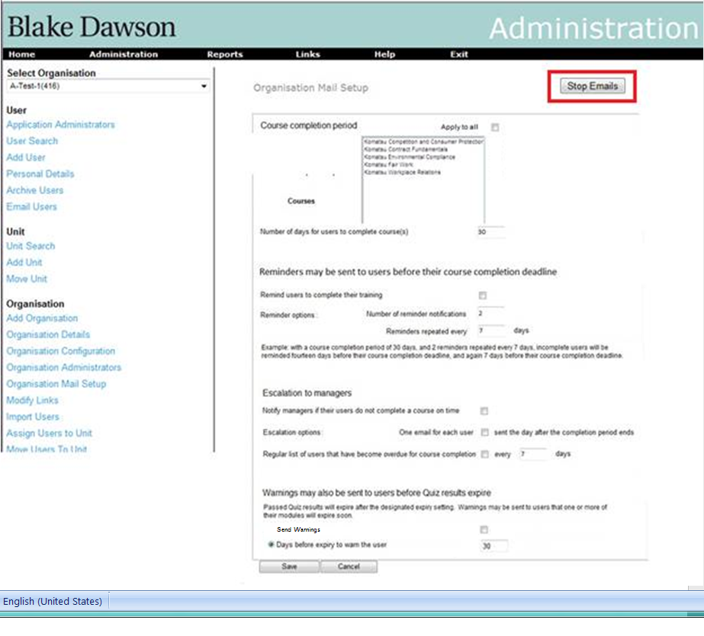

When mail for an Organisation is stopped the following changes occur:

* The Report Queuing Service does not render Reports for that Organisation however it still processes the schedules as they become due for delivery and it will create Emails to the users specified in the schedules that simply contain a body containing the words “%Reportname% not rendered – mail is halted” (where %Reportname% contains the actual name of the Report). This message may be customized in Organisation Config.
* The Mail sending service will not send Emails for that Organisation. Instead of removing the message from tblEmailQueue, sending the message and transferring it to tblEmail the service will simple remove the message from tblEmailQueue and add it to tblPurgedEmails.
* The Mail queueing service will continue to function with no changes in behaviour.

Along with this, the SALT admin will have an additional button on the “Mail Throughput” screen. This will stop all emails sent by the entire site (see the screenshot below).

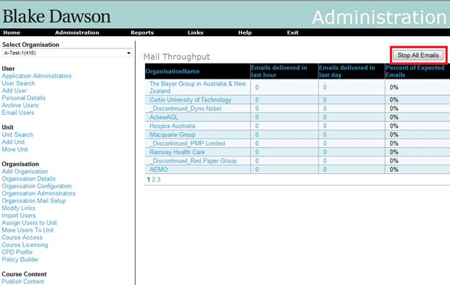

These buttons can be toggled, meaning once pressed they would provide option to enable sending the emails again. When the screens are first loaded the button has appropriate text for the condition of the services. (i.e. the org admins button will be a “Stop” button when the organisation is flagged for sending of mail or it will be a “Start” button if the Organisation is flagged to not send mail and the SALT Admins button will be a “Stop” button when the Mail sending Service is interrogated and returns “running” and will be a “Start” button when the Mail sending Service is interrogated and returns “stopped”)

When the SALT admin presses the “Stop all Email” on the “Mail Throughput” screen these changes occur

* The Report Queuing Service is restarted after which it does not render Reports for any Organisation however it still processes the schedules as they become due for delivery and it will create Emails to the users specified in the schedules that simply contain a body containing the words “%Reportname% not rendered – mail is halted” (where %Reportname% contains the actual name of the Report). This message will not be localised.
* The Mail sending service is stopped.
* The Mail queuing service is restarted after which it will continue to function with no changes in behaviour.

When the SALT admin presses the “Start all Email” on the “Mail Throughput” screen these changes occur

* The Report Queuing Service resumes normal activity.
* All messages will be moved from tblEmailQueue to tblPurgedEmails.
* The Mail sending service is started.
* The Mail queuing service will continue to function with no changes in behaviour.

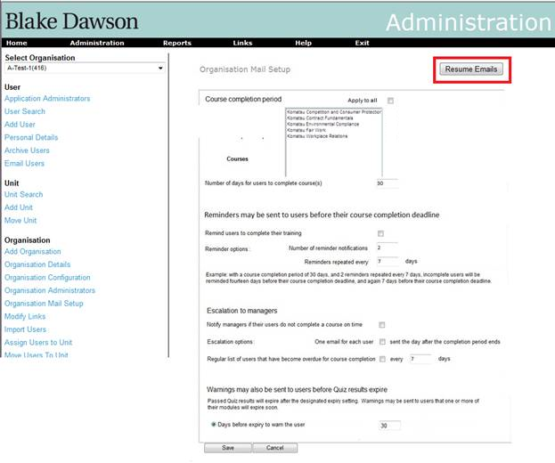

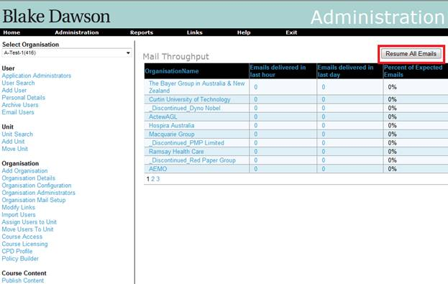

The dropped emails may not be re-sent. Even though emails will be created, queued and deleted from the application during this period when the “Stop Emails” button is pressed, they will be maintained in database for audit purpose.

Audit tables for sent Emails and Deleted Emails do not/will not contain Attachments.

The only Emails that will be stopped during the time that the “Stop Emails” button is pressed are Emails that are generated by the Mail Sending Service and the Mail Queuing Service, Emails generated directly from ASP pages will continue to be sent.

# 10. Replace the user of the word “Delinquency” or “Delinquent” with ”Overdue”.

Requirement: Replace the user of the word “Delinquency” or “Delinquent” with Overdue.

The phrase “At Risk of Delinquency” will be replaced with the phrase ”At Risk of becoming Overdue”.

# 11. reports are grouped by category

## Requirements

To modify the Salt4.2 Report menu so that reports are grouped by category as per the following table.

|  |  |
| --- | --- |
|  |  |
|  |  |
| **User Activity Reports** | |
|  | Current Admin Report |
|  | Course Status Report |
|  | Completed Users Report |
|  | At Risk Report |
|  | Warning Report |
|  | Progress Report |
|  | Historic Admin Report |
|  |  |
| **Organisation Reports** | |
|  | Summary Report |
|  | Trend Report |
|  |  |
| **Email Reports** | |
|  | Email Report |
|  | CPD Email Report |
|  | Policy Email Report |
|  | Sent Email Report |
|  |  |
| **Administration Reports** | |
|  | User Detail Report |
|  | Active / Inactive Users Report |
|  | Licensing Report |
|  | Unit Pathway Report |
|  | Unit Compliance Report |
|  | Unit Administrator Report |
|  |  |
| **CPD Reports** | |
|  | CPD Report |
|  |  |
| **Policy Reports** | |
|  | Policy Builder Report |
|  |  |

All category names will be localized (with the English version of the localization supplied)

When an Organisation does not have CPD access neither the “**CPD Reports**” category or the “CPD Report” link will be visible.

When an Organisation does not have Policy Builder access then neither the “**Policy Reports**” category or the “Policy Builder Report” link will be visible.

# Implementation

The 6 category names must be created in the localization tables for the GLOBAL.UserControls.ReportsMenu.ascx interface.

Changes will be made to ReportsMenu.ascx to display the labels.

Changes will be made to ReportsMenu.ascx.cs to hide the categories when they should not be visible.

# Testing

Testing should be done in all user contexts:

* Student
* Unit Admin
* Org Admin
* App Admin

# 12. Historic Admin Report default date mod.

The “Historic Date” on the Historic Admin Report will default to yesterday.

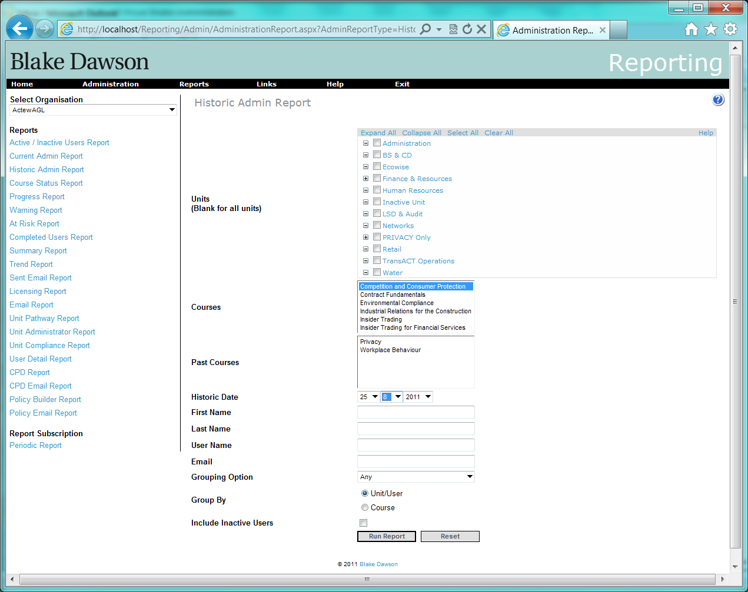

# 13. Licensing Report control changes.

The grid on the Licensing Report will be modified as shown: 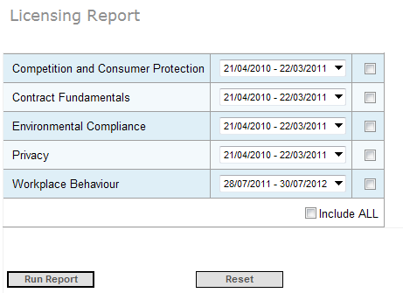

# 14. Add a %FirstName% parameter substitution variable to all Reports.

All reports that use templates from Organisation Configuration screen will be modified so that they will replace the pattern %FirstName% with the recipients Firstname.

Please specifiy behaviour with respect to multiple TO: recipients and multiple CC: Recipients.

Will the code that uses each of the following templates be modified?

|  |  |  |
| --- | --- | --- |
| Name | Description | Value |
| Email_Report_Complete_To_Administrators | Email to Completed Users Administrators | <BR>Hi,<BR>The following users have completed their %APP_NAME% %COURSE_NAME% course between %DATE_FROM% and %DATE_TO%:<BR>%USER_LIST%<BR>Regards,<BR>%APP_NAME% Administrator |
| Email_Report_InComplete_To_Administrators | Email to Incompleted Users Administrators | <BR>Hi,<BR>The following users have not completed their %APP_NAME% %COURSE_NAME% course<BR>%USER_LIST%<BR>Regards,<BR>%APP_NAME% Administrator |
| Email_Report_Failed_To_Administrators | Email to Failed Users Administrators | <BR>Hi,<BR>The following users have failed some of their testing in the %APP_NAME% %COURSE_NAME% course.<BR>%USER_LIST%<BR>Regards,<BR>%APP_NAME% Administrator |
| Email_Report_Not_Started_Administrators | Email to Not Started Users Administrators | <BR>Hi,<BR>The following users have not started some of their testing in the %APP_NAME% %COURSE_NAME% course.<BR>%USER_LIST%<BR>Regards,<BR>%APP_NAME% Administrator |
| Email_Report_Complete_To_Users | Email to Completed Users | <BR>Hi,<BR>Congratulations!  You have completed the following %APP_NAME% courses:<BR> %COURSE_NAMES%<BR><BR>Please log on to the %APP_NAME% Online Compliance Training website to print your certificate of completion.<BR>Thank you for your efforts.<BR>Regards,<BR>%APP_NAME% Administrator |
| Email_Report_Incomplete_To_Users | Email to InCompleted Users | <BR>Hi,<BR>Our records show that you have not completed the following %APP_NAME% courses:<BR> %COURSE_NAMES%<BR><BR>Please return to the %APP_NAME% Online Compliance Training website and complete all outstanding quizzes.<BR>It is recommended that you review the lessons before attempting a quiz.<BR>Regards,<BR>%APP_NAME% Administrator |
| Email_Report_Failed_To_Users | Email to Failed Users | <BR>Hi,<BR>Our records show that you have failed some of the following %APP_NAME% courses:<BR> %COURSE_NAMES%<BR><BR>Please return to the %APP_NAME% Online Compliance Training website and redo your failed quizzes.<BR>It is also recommended that you review the lesson before attempting the quiz.<BR>Regards,<BR>%APP_NAME% Administrator |
| Email_Report_Not_Started_To_Users | Email to Not Started Users | <BR>Hi,<BR>Our records show that you have not started the following %APP_NAME% courses:<BR> %COURSE_NAMES%<BR><BR>Please log on to the %APP_NAME% Online Compliance Training website and complete all outstanding quizzes.<BR>It is recommended that you review the lesson before attempting a quiz.<BR>Regards,<BR>%APP_NAME% Administrator |
| Email_Report_Expired_Time_Elapsed_To_Administrators | Email to Expired (Time Elapsed) Administrators | <BR>Hi,<BR>The following users have Expired (Time Elapsed) for some of their testing in the %APP_NAME% %COURSE_NAME% course.<BR>%USER_LIST%<BR>Regards,<BR>%APP_NAME% Administrator |
| Email_Report_Expired_New_Content_To_Administrators | Email to Expired (New Content) Administrators | <BR>Hi,<BR>The following users have Expired (New Content) for some of their testing in the %APP_NAME% %COURSE_NAME% course.<BR>%USER_LIST%<BR>Regards,<BR>%APP_NAME% Administrator |
| Email_Report_Expired_New_Content_To_Users | Email to Expired (New Content) Users | <BR>Hi,<BR>Our records show that you have new content for the following %APP_NAME% courses requiring completion:<BR> %COURSE_NAMES%<BR><BR>Please return to the %APP_NAME% Online Compliance Training website and complete all outstanding quizzes.<BR>It is recommended that you review the lesson before attempting a quiz.<BR>Regards,<BR>%APP_NAME% Administrator |
| Email_Report_Expired_Time_Elapsed_To_Users | Email to Expired (Time Elapsed) Users | <BR>Hi,<BR>Our records show that your training for the following %APP_NAME% courses has expired:<BR> %COURSE_NAMES%<BR><BR>Please return to the %APP_NAME% Online Compliance Training website and complete all outstanding quizzes.<BR>It is recommended that you review the lesson before attempting a quiz.<BR>Regards,<BR>%APP_NAME% Administrator |
| Email_Incomplete_CPD_User | Email to Incomplete CPD Users | <BR>Hi,<BR>Our records show that you have not completed your Continuous Professional Development requirements.<BR>Please log on to the %APP_NAME% Online Compliance Training website and complete any modules where applicable.<BR>Regards,<BR>%APP_NAME% Administrator |
| Email_Incomplete_CPD_Administrator | Email to Incomplete CPD Administrator | <BR>Hi,<BR>The following users have not completed their Continuous Professional Development requirements.<BR>%USER_LIST%<BR>Regards,<BR>%APP_NAME% Administrator |
| Policy_Email_Report_Accepted_To_Users | Policy_Email to Accepted Users | <BR>Hi,<BR>Thank You for taking the time to Read and accept the %POLICY% policy <BR><BR>Regards,<BR>%APP_NAME% Administrator |
| Policy_Email_Report_Not_Accepted_To_Users | Policy_Email to Not Accepted Users | <BR>Hi,<BR>Our Records show that you have not logged into %APP_NAME% to read and acknowledge the following policy: <BR> %POLICY% <BR> Please login into %APP_NAME% Online Compliance Training to access the policies assigned to you.<BR><BR>Regards,<BR>%APP_NA |
| Policy_Email_Report_Accepted_To_Administrators | Policy_Email to Accepted Users Administrators | <BR>Hi,<BR>The following users have accepted their %POLICY% policy between %DATE_FROM% and %DATE_TO%:<BR>%USER_LIST%<BR>Regards,<BR>%APP_NAME% Administrator |
| Policy_Email_Report_Not_Accepted_To_Administrators | Policy_Email to Not Accepted Users Administrators | <BR>Hi,<BR>The following users have not read their %POLICY% policy between %DATE_FROM% and %DATE_TO%:<BR>%USER_LIST%<BR>Regards,<BR>%APP_NAME% Administrator |
| Student_Summary_Header | Student Summary Header | Hi, Our Records show that the following changes have occured to your course status for  %APP_NAME%:<BR> |
| Student_Summary_Sig | Student Summary Sig | <BR>Regards,%APP_NAME% Administrator |
| Student_Summary_ExpiredContent | Student Summary - Expired Content | The content of the following Courses - Modules has been updated and you are required to redo them:<BR> |
| Student_Summary_PassedCourses | Student Summary -Passed Courses | Congratulations on passing the following courses:<BR> |
| Student_Summary_PassedModules | Student Summary - Passed Modules | Congratulations on passing the following modules:<BR> |
| Student_Summary_AtRiskOfExpiry | Student Summary - At Risk Of Expiry | Your quiz results for the following Courses (Modules) will expire unless you complete the entire course before the dates shown:<BR> |
| Student_Summary_AtRiskOfBeingOverdue | Student Summary - At Risk Of being Overdue | You were nominated to complete the following courses before the dates shown however our records indicate that the courses are not finished at this time.<BR> Please ensure that the courses are finished by the nominated dates:<BR> |
| Student_Summary_Subject | Student Summary Message Subject | %APP_NAME%  Summary. |
| Overdue_Summary_Header | Overdue Summary Header | Hi, The Following students are now Overdue for their %APP_NAME% courses:<BR> |
| Overdue_Summary_Sig | Overdue Summary Sig | <BR>Regards,%APP_NAME% Administrator |
| Overdue_Summary_Subject | Overdue Summary Message Subject | %APP_NAME%  Overdue Summary. |
| Student_Summary_NewStarter | Student Summary - New Starter Greeting | You have been registered for use of the %APP_NAME% WebSite at %URL%, <BR>Your UserName is %USERNAME% and your initial password is %PASSWORD%. <BR>Please login and change your password as soon as possible. |
| Course_Completion_Certificate | Course Completion Certificate | Congratulations %USERNAME% on passing the %APP_NAME%  %COURSE% , your completion certificate is attached or may be reprinted from the website at %URL%. |
| Email_Failure_delivery_notification | Email Failure delivery notification | Email Failure delivery notification, the following message failed to be sent for 3 days to the following email address: |

# Appendix 1

## new fields in tblReportSchedule

New fields highlighted in yellow

|  |  |  |
| --- | --- | --- |
| ScheduleID | int |  |
| UserID | int |  |
| ReportID | int |  |
| LastRun | datetime | Last date on which the Report was delivered |
| NextRun | datetime | Next date on which the Report will be delivered |
| ReportDuration | int | Not used |
| ReportDurationPeriod | char(1) | Not used |
| ReportStartDate | datetime | First day report will be delivered on |
| ReportFrequency | int | Interval |
| ReportFrequencyPeriod | char(1) | D = Day  W = Week  M = Month  Y = Year |
| DocumentType | char(1) |  |
| ParamOrganisationID | int |  |
| ParamCompleted | char(1) |  |
| ParamStatus | char(1) |  |
| ParamFailCount | int |  |
| ParamCourseIDs | nvarchar(800) |  |
| ParamHistoricCourseIDs | nvarchar(800) |  |
| ParamAllUnits | char(1) |  |
| ParamTimeExpired | int |  |
| ParamTimeExpiredPeriod | char(1) |  |
| ParamQuizStatus | char(1) |  |
| ParamGroupBy | char(1) |  |
| ParamGroupingOption | int |  |
| ParamFirstName | nvarchar(200) |  |
| ParamLastName | nvarchar(200) |  |
| ParamUserName | nvarchar(200) |  |
| ParamEmail | nvarchar(200) |  |
| ParamIncludeInactive | char(1) |  |
| ParamSubject | nvarchar(200) |  |
| ParamBody | nvarchar(200) |  |
| ParamProfileID | int |  |
| ParamOnlyUsersWithShortfall | char(1) |  |
| ParamEffectiveDate | datetime | Used when IsPeriodic = N or O |
| ParamSortBy | char(1) |  |
| ParamClassificationID | int |  |
| ParamUnitIDs | nvarchar(MAX) |  |
| ParamLangCode | nvarchar(10) |  |
| **IsPeriodic** | **Char(1)** | **N = Now**  **O = Once Only**  **M = More than once** |
| ParamDateTo | datetime | Used when IsPeriodic = N or O |
| ParamDateFrom | datetime | Used when IsPeriodic = N or O |
| ParamLicensingPeriod | int |  |
| ParamProfilePeriodID | int |  |
| **ReportEndDate** | **datetime** | **Last date that Report can be delivered on.** |
| **ReportTitle** | **nvarchar(100)** | **Report Title** |
| **NumberOfReports** | **int** | **Number of times report is delivered** |
| **ReportPeriodType** | **int** | **1 = all**  **2 = precceding N days**  **3 = From specified date to report date** |
| **ReportFromDate** | **datetime** | **The DateFrom when ReportPeriodType = 3** |
|  |  |  |
| **CCList** | **varchar(MAX)** | **Comma separated list of CC userIDs** |
| **LastUpdatedBy** | **int** | **UserID of last person to edit the schedule** |
| **LastUpdated** | **datetime** |  |
|  |  |  |
|  |  |  |
|  |  |  |

## definition of new table tblSchedulesAudit

|  |  |  |
| --- | --- | --- |
| AuditID | int | Autoincrement key |
| ScheduleID | int |  |
| UserID | int |  |
| ReportID | int |  |
| LastRun | datetime | Last date on which the Report was delivered |
| NextRun | datetime | Next date on which the Report will be delivered |
| ReportDuration | int | Not used |
| ReportDurationPeriod | char(1) | Not used |
| ReportStartDate | datetime | First day report will be delivered on |
| ReportFrequency | int | Interval |
| ReportFrequencyPeriod | char(1) | D = Day  W = Week  M = Month  Y = Year |
| DocumentType | char(1) |  |
| ParamOrganisationID | int |  |
| ParamCompleted | char(1) |  |
| ParamStatus | char(1) |  |
| ParamFailCount | int |  |
| ParamCourseIDs | nvarchar(800) |  |
| ParamHistoricCourseIDs | nvarchar(800) |  |
| ParamAllUnits | char(1) |  |
| ParamTimeExpired | int |  |
| ParamTimeExpiredPeriod | char(1) |  |
| ParamQuizStatus | char(1) |  |
| ParamGroupBy | char(1) |  |
| ParamGroupingOption | int |  |
| ParamFirstName | nvarchar(200) |  |
| ParamLastName | nvarchar(200) |  |
| ParamUserName | nvarchar(200) |  |
| ParamEmail | nvarchar(200) |  |
| ParamIncludeInactive | char(1) |  |
| ParamSubject | nvarchar(200) |  |
| ParamBody | nvarchar(200) |  |
| ParamProfileID | int |  |
| ParamOnlyUsersWithShortfall | char(1) |  |
| ParamEffectiveDate | datetime | Used when IsPeriodic = N or O |
| ParamSortBy | char(1) |  |
| ParamClassificationID | int |  |
| ParamUnitIDs | nvarchar(MAX) |  |
| ParamLangCode | nvarchar(10) |  |
| **IsPeriodic** | **Char(1)** | **N = Now**  **O = Once Only**  **M = More than once** |
| ParamDateTo | datetime | Used when IsPeriodic = N or O |
| ParamDateFrom | datetime | Used when IsPeriodic = N or O |
| ParamLicensingPeriod | int |  |
| ParamProfilePeriodID | int |  |
| **ReportEndDate** | **datetime** | **Last date that Report can be delivered on.** |
| **ReportTitle** | **nvarchar(100)** | **Report Title** |
| **NumberOfReports** | **int** | **Number of times report is delivered** |
| **ReportPeriodType** | **int** | **1 = all**  **2 = precceding N days**  **3 = From specified date to report date** |
| **ReportFromDate** | **datetime** | **The DateFrom when ReportPeriodType = 3** |
|  |  |  |
| **CCList** | **varchar(MAX)** | **Comma separated list of CC userIDs** |
| **LastUpdatedBy** | **int** | **UserID of last person to edit the schedule** |
| **LastUpdated** | **datetime** |  |
|  |  |  |
|  |  |  |
|  |  |  |

## definition of new table tblOrganisationCourseNotifyOptions

|  |  |  |
| --- | --- | --- |
| **name** | **type** | **Default value** |
| OrgCourseNotifyID | int | autoincrement |
| OrganisationID | int |  |
| CourseID | int |  |
| NotifyManagers | bit | 0 |
| SummaryAllUsers | bit | 1 |
| SummaryPeriodType | char(1) | D |
| SummaryPeriod | int | 1 |
|  |  |  |

/* To prevent any potential data loss issues, you should review this script in detail before running it outside the context of the database designer.*/

BEGIN TRANSACTION

SET QUOTED_IDENTIFIER ON

SET ARITHABORT ON

SET NUMERIC_ROUNDABORT OFF

SET CONCAT_NULL_YIELDS_NULL ON

SET ANSI_NULLS ON

SET ANSI_PADDING ON

SET ANSI_WARNINGS ON

COMMIT

BEGIN TRANSACTION

GO

CREATE TABLE dbo.tblOrganisationCourseNotifyOptions

(

OrgCourseNotifyID int NOT NULL IDENTITY (1, 1),

OrganisationID int NOT NULL,

CourseID int NOT NULL,

NotifyManagers bit NOT NULL,

SummaryAllUsers bit NOT NULL,

SummaryPeriodType char(1) NOT NULL,

SummaryPeriod int NOT NULL

) ON [PRIMARY]

GO

ALTER TABLE dbo.tblOrganisationCourseNotifyOptions ADD CONSTRAINT

DF_tblOrganisationCourseNotifyOptions_NotifyManagers DEFAULT 0 FOR NotifyManagers

GO

ALTER TABLE dbo.tblOrganisationCourseNotifyOptions ADD CONSTRAINT

DF_tblOrganisationCourseNotifyOptions_SummaryAllUsers DEFAULT 1 FOR SummaryAllUsers

GO

ALTER TABLE dbo.tblOrganisationCourseNotifyOptions ADD CONSTRAINT

DF_tblOrganisationCourseNotifyOptions_SummaryPeriodType DEFAULT 'D' FOR SummaryPeriodType

GO

ALTER TABLE dbo.tblOrganisationCourseNotifyOptions ADD CONSTRAINT

DF_tblOrganisationCourseNotifyOptions_SummaryPeriod DEFAULT 1 FOR SummaryPeriod

GO

ALTER TABLE dbo.tblOrganisationCourseNotifyOptions SET (LOCK_ESCALATION = TABLE)

GO

COMMIT

select Has_Perms_By_Name(N'dbo.tblOrganisationCourseNotifyOptions', 'Object', 'ALTER') as ALT_Per, Has_Perms_By_Name(N'dbo.tblOrganisationCourseNotifyOptions', 'Object', 'VIEW DEFINITION') as View_def_Per, Has_Perms_By_Name(N'dbo.tblOrganisationCourseNotifyOptions', 'Object', 'CONTROL') as Contr_Per